Project Report for Logic University Stationery Requisition System

Team 8

Members:

Koh Zhen Xiang

Antonio

Udaya Bhaskar Reddy

Kotha Prasanth Reddy

Neo Wei Sheng

Kyaw Sithu

Wee Hui Ching

Harbinder Singh Gill

Table of Contents

**1.0 Introduction** **5**

**2.0 Product Deliverables** **6**

2.1 Requirement Capture Workflow 6

2.1.1 Requirement Specification (Function) 6

2.1.1.1 Use Case 6

2.1.1.2 Actors 7

2.1.1.3 Domain Model 7

2.1.2 Requirement Specification (Non Functional) 8

2.1.2.1 System Architecture 8

2.1.2.2 System Performance Requirements 8

2.1.2.3 Response Time 8

2.1.2.4 User Volume Table 8

2.1.2.5 Volume of Business Transaction 9

2.1.2.6 Data Volume 11

2.1.2.7 Security Requirements 12

2.1.2.7.1 Mobile Application 12

2.1.2.7.2 Web Application 12

2.1.3 UI Specifications 15

2.1.3.1 Department UI 15

2.1.3.2 Department Android UI 26

2.1.3.3 Store UI 32

2.2 Architectural Platform 54

2.3 Sequence Diagram 55

2.3.1 Department Sequence Diagram 55

2.3.1.1 Create Requisition Form 55

2.3.1.2 Approve Requisition Form 55

2.3.1.3 Appoint Substitute Approver 56

2.3.1.4 Appoint Department Representative 56

2.3.1.5 Set Collection Point 57

2.3.2 Department (Android) Sequence Diagram 58

2.3.2.1 Set Collection Point 58

2.3.2.2 Appoint Substitute Approver 58

2.3.2.3 Appoint Department Representative 59

2.3.3 Store Sequence Diagram 60

2.3.3.1 Retrieve Product Info 60

2.3.3.2 Retrieve Stock Card 60

2.3.3.3 Maintain Stationery Details 61

2.3.3.4 Maintain Supplier Details 61

2.3.3.5 Maintain Department Details 62

2.3.3.6 Consolidated Request List 62

2.3.3.7 Create Adjustment Voucher 63

2.3.3.8 View Low Stock Inventory 63

2.3.3.9 View Inventory List 64

2.3.3.10 View Stationery Requisition Trends 64

2.3.3.11 View Department Requisition Trends 65

2.3.3.12 Approve Adjustment Request- Store Supervisor 65

2.3.3.13 Approve Adjustment Request- Store Supervisor 66

2.3.3.14 Maintain Purchase Order 66

2.3.3.15 Approve Purchase Order 67

2.3.3.16 View Disbursement List 67

2.3.3.17 Confirm Disbursement List 68

2.3.3.18 Create Outstanding Order 68

2.3.3.19 Update Item Quantity 69

2.4 Class Diagram 70

2.4.1 Department Class Diagram 70

2.4.1.1 Collection Point 70

2.4.1.2 Appoint Department Representative and Substitute Approver 70

2.4.1.3 Create And Approve Request 71

2.4.2 Department (Android) Class Diagram 72

2.4.2.1 Appoint Department Representative and Substitute Approve 72

2.4.2.2 Collection Point 73

2.4.3 Store Class Diagram 74

2.4.3.1 Maintain Stationery Details 74

2.4.3.2 Maintain Supplier Details 75

2.4.3.3 Maintain Department Details 76

2.4.3.4 Consolidated Request List 77

2.4.3.5 Purchase Order 78

2.4.3.6 Disbursement List 78

2.4.3.7 Updating of Item Quantity 79

2.4.3.8 Creating Outstanding Order 79

2.5 Statechart Diagram For Store and Department 80

2.5.1 Store 80

2.5.2 Department 80

2.6 Relational DB Design 81

2.7 Test Plan 82

2.7.1 Department 82

2.7.2 Store 87

**3.0 Recommendations** **93**

**4.0 Lessons Learned** **94**

**5.0 Problems and Solution** **95**

**6.0 Looking Back** **96**

# 

# 1.0 Introduction

The team has been tasked to create a stationery inventory system that aims to reduce the amount of manual work needed and to increase the efficiency in which stationery is disbursed to the University Departments.

In turn, this will allow stationery store staff more time to attend to other matters instead of being thoroughly focused on maintaining inventory. The system also aims to reduce communication breakdown, by providing a series of notifications that are pushed to different respective users to prompt them for any action required.

We will be covering the entire project SDLC, from gathering user requirement to UAT and deployment. Stages include:

1. User Requirement Gathering: Including coming up with the sequence diagram, use cases.
2. UI prototype presentation: This includes the first draft of screens that the team has come up with to present to the user to get a feel of user sentiment.
3. User acceptance: The team has prepared the system walkthrough that will be gone through with users.

# 2.0 Product Deliverables

## 2.1 Requirement Capture Workflow

### 2.1.1 Requirement Specification (Function)

#### 2.1.1.1 Use Case

#### 2.1.1.2 Actors

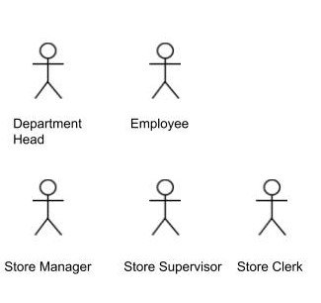

#### 2.1.1.3 Domain Model

#### 

##### 

### 2.1.2 Requirement Specification (Non Functional)

#### 2.1.2.1 System Architecture

The Logic University campus is linked by a local area network. Each employee is provided with a PC, which they can use for accessing email and any other work-related purposes. A printer will be shared among every 4 to 5 employees. There is also a printer set-up in the Stationery Store Department. All the servers, including printer server and database server, are located in a secured computer room within the campus.

#### 2.1.2.2 System Performance Requirements

The web application system will be available during office hours (9am - 5pm Mon to Fri; 9am - 12pm Sat). The mobile application would be available 24 hours a day, 7 days a week.

#### 2.1.2.3 Response Time

The system would take roughly 2 seconds to navigate between screens.

#### 2.1.2.4 User Volume Table

|  |  |  |
| --- | --- | --- |
| User Group | Country/Location/Count | Remarks |
| Department Head | Singapore/Department/1 | Department head is stationed at their respective department and needs to use the system regularly. |
| Department Staff | Singapore/Department/49 | Department staff is stationed at their respective department and is one of the most frequent users of the system. |
| Store Clerk | Singapore/Stationery Store/3 | Store Clerk is stationed at the stationery store and is the most frequent user of the system. |
| Store Supervisor | Singapore/Stationery Store/1 | Store Supervisor is stationed at the stationery store and needs to use the system regularly. |
| Store Manager | Singapore/Stationery Store/1 | Store Manager is stationed at the stationery store and needs to use the system regularly. |

#### 2.1.2.5 Volume of Business Transaction

|  |  |  |  |  |
| --- | --- | --- | --- | --- |
| Business Transaction | Business Criticality | No.of Users | Transaction Information | Concurrently Important Activities |
| Login to System | Critical | 500 | 1/day/staff |  |
| Create Requisition Form | Critical | 500 | 1/week/staff |  |
| Appoint Department Representative | Moderate | 10 | 1/week/department head |  |
| Appoint Substitute Approver | Low | 10 | 1/week/department head |  |
| Appoint Collection Point | Moderate | 10 | 1/week/department head |  |
| Approve Requisition Form | Critical | 10 | 1/week/department head |  |
| Maintain Stationery Catalogue | Low | 5 | 1/year/store staff |  |
| Maintain Supplier List | Low | 5 | 1/year/store staff |  |
| Maintain Adjustment Voucher | Moderate | 5 | 1/month/store staff |  |
| Maintain Inventory Status Report | Moderate | 5 | 1/month/store staff |  |
| Approve Adjustment Request | Moderate | 2 | 1/month/store staff |  |
| Create PO | Critical | 3 | 1/week/store clerk |  |
| Approve PO | Critical | 1 | 1/week/store supervisor |  |
| Search Disbursement List | Moderate | 500 | 1/month/staff |  |
| Generate Disbursement List | Critical | 5 | 1/week/store staff |  |
| Maintain Inventory Retrieval List | Critical | 5 | 1/week/store staff |  |
| Maintain Consolidated Request Form | Critical | 5 | 1/week/store staff |  |

### 

#### 2.1.2.6 Data Volume

|  |  |  |  |
| --- | --- | --- | --- |
| Business Entity Class | Source Document | Retention Period | Target Volume |
| Stationery List | Product Information | 2 years | Logic University has a catalogue of 90 products and each product has its own product information. Assuming 10 products are brought in each year,  Current Products: 90  2 year: 90 + 10 x 2 = 110 |
| Employee List | Employee Information | 5 years | The increase in the number of employees would be up to the discretion of the university administration. |
| Inventory List | Available Stock Information | 5 years | Assuming that 80% of stationeries is replenished every year  Current Products: 90  Total replenish in a year: 90 x 80% = 72 |
| Disbursement List | Stock Issued Information | 5 years | Assuming that there is at least 1 disbursement list per department a week  Current Year = 52 x 10 x 1 = 520  5 yrs: 520 x 5 = 2,600 |
| Requisition Form List | Order Information | 5 years | Assuming that 10% of employee request for stationery per week  Current year : 52 x 500 x 10% = 2,600  5 yrs: 2600 x 5 = 13,000 |
| Collection Point List | Collection Point Information | 1 year | There would not be any changes to the collection. |
| Adjustment Voucher List | Adjustment Information | 5 years | Assuming that there is at least adjustment voucher a month  Current Year = 12 x 1 = 12  5 yrs: 12 x 5 = 60 |
| Consolidated Order List | Consolidated Order Information | 5 years | Since there is an order for the stationery every week, this would mean that there would be a consolidated order list every week as well.  Assuming every year: 52 weeks  5 years: 52 x 5 = 260 |
| Supplier List | Supplier Information | 3 years | Since the suppliers has to go through a tender process and there is a fixed amount of suppliers that would be awarded the tender, there would be no increase in the number of suppliers. |
| Department List | Department Information | 3 years | There would be no increase in the number of departments. |

#### 2.1.2.7 Security Requirements

##### 2.1.2.7.1 Mobile Application

For mobile application, it is only to be used by the department head. This would mean that only department head would have full access to maintain the application.

##### 2.1.2.7.2 Web Application

|  |  |  |  |  |  |
| --- | --- | --- | --- | --- | --- |
| Data (Entity Class) / User Role (Actor) | Department Head | Department Staff | Store Clerk | Store Supervisor | Store Manager |
| Login to System | R,U | R,U | R,U | R,U | R,U |
| Create Requisition Form | C,R,U,D | C,R,U,D | - | - | - |
| Appoint Department Representative | R,U | - | - | - | - |
| Appoint Substitute Approver | R,U | - | - | - | - |
| Appoint Collection Point | R,U | - | - | - | - |
| Approve Requisition Form | R,U | - | - | - | - |
| Maintain Stationery Catalogue | R | R | C,R,U,D | R | R |
| Maintain Supplier List | - | - | R | R | C,R,U,D |
| Maintain Adjustment Voucher | - | - | C,R,U,D | R,U | R,U |
| Maintain Low Status Stock Report | - | - | R,U | - | - |
| Maintain Department List | - | - | R,U | R | R |
| Check Stock Card | - | - | R | R | R |
| Maintain Inventory Status Report | - | - | R,U | - | - |
| Approve Adjustment Request | - | - | - | R,U | R,U |
| Generate Stationery Requisition Trends | - | - | - | R,U | - |
| Generate Department Requisition Trends | - | - | - | R,U | - |
| Create PO | - | - | C,R,U,D | - | - |
| Search PO | - | - | R,U,D | - | - |
| Approve PO | - | - | - | R,U | R,U |
| Maintain Disbursement List | - | - | C,R,U,D | - | - |
| Search Disbursement List | R | R | R | R | R |
| Generate Disbursement List | - | - | C,R,U,D | - | - |
| Maintain Inventory Retrieval List | - | - | C,R,U,D | - | - |
| Search Inventory Retrieval List | - | - | R,U,D | - | - |
| Generate Inventory Retrieval | - | - | R | - | - |
| Maintain Consolidated Request Form | - | - | C,R,U,D | - | - |

C = Create, R = Read, U = Update, D = Delete

### 

### 2.1.3 UI Specifications

#### 2.1.3.1 Department UI

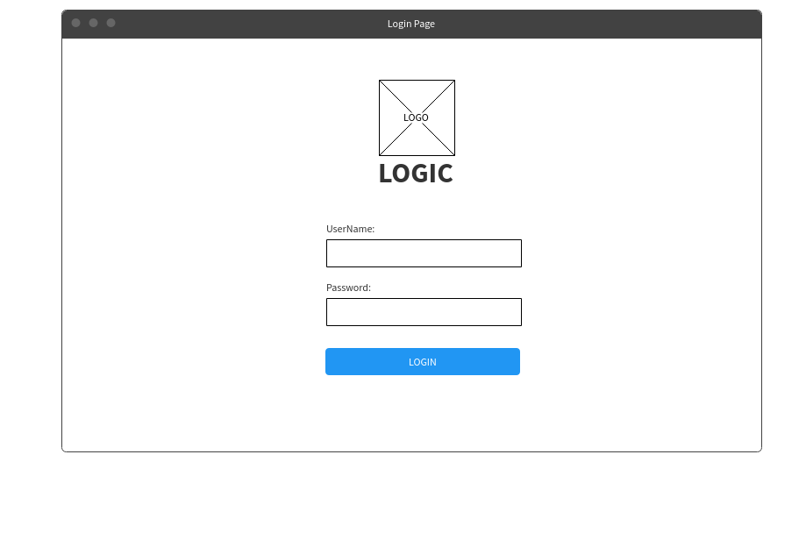

This is the login screen which will be used by the department head and employee.

Department Log In UIs

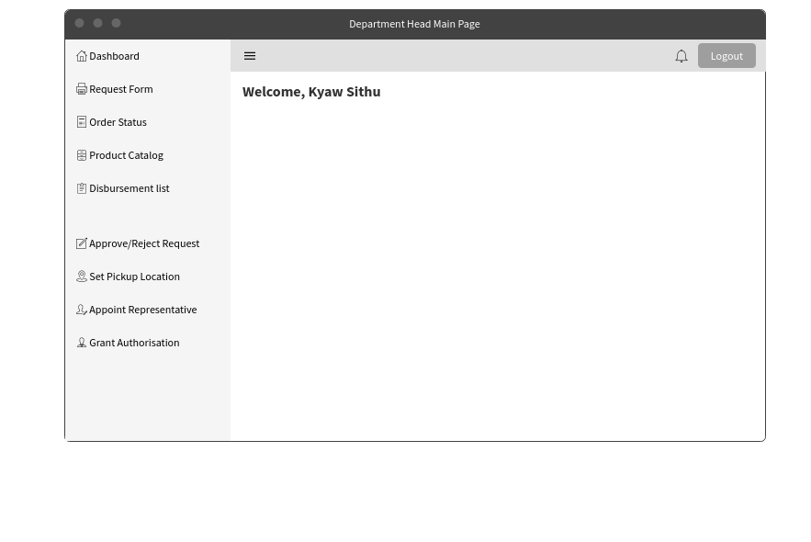

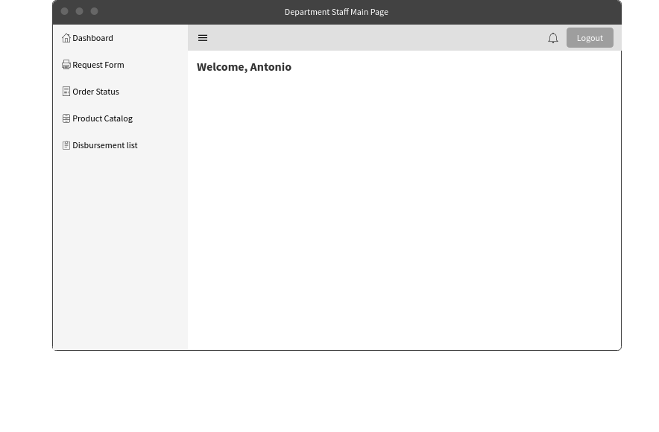

These 2 screens are the main pages after logging in. The one above will be viewed by the department head while the one below will be viewed by the staff.

Stationery Requisition Form

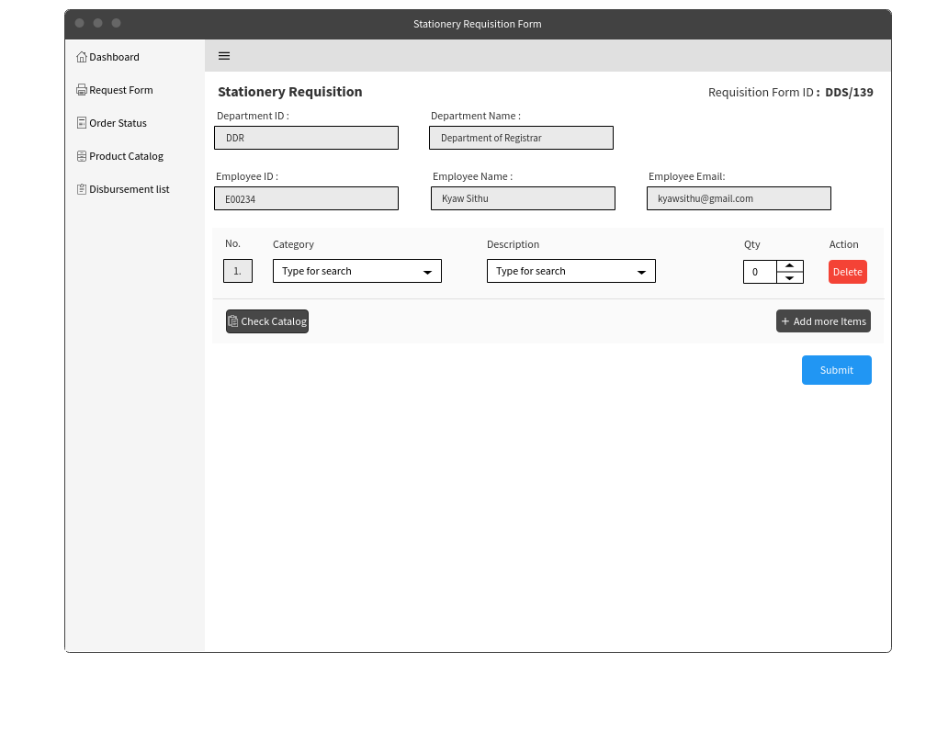

Upon clicking on the request form, the above page will be shown. This page is to submit a request for items that are needed in the department. Users will first select from a Category of item (i.e Pen, Envelope, Paper etc). Once selected, the category’s specific item selection will be presented in a dropdown box. A check catalog button has been included to pop-up a catalogue window in case there is a need to refer to it.

View Order Status

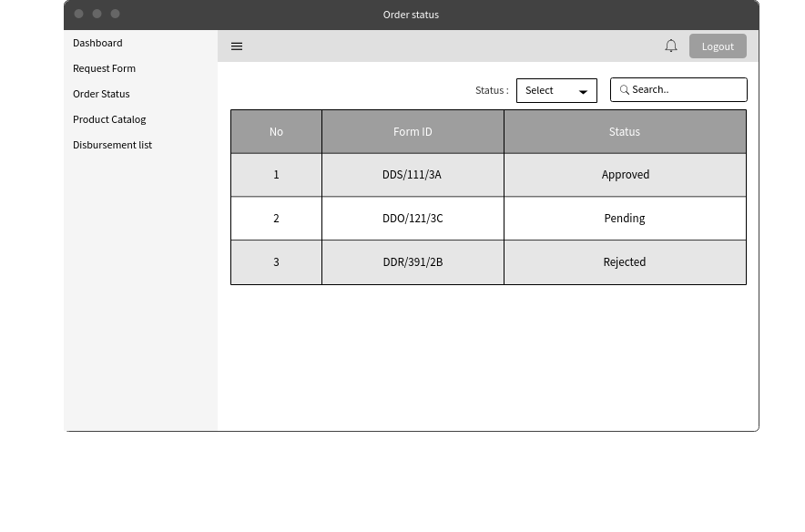

This page is the order status page and can be accessed after clicking on the order status on the left side of the page. Tracking of the form’s status can be done here. Sorting of the status can be done from the drop-down list and searching for specific form can also be done by searching for its unique form ID.

View Order Status - Specific Selection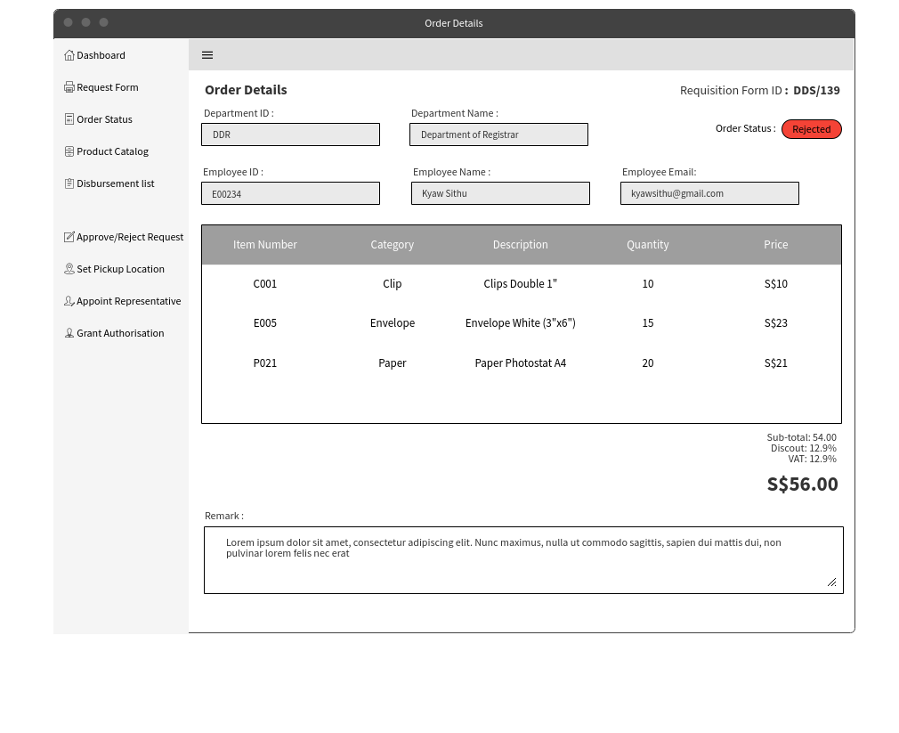

This is the screen after clicking on specific form ID on the order status. The employee can view the detailed version of what they have ordered and the remark provided by the manager is he rejects it.

View Stationery Catalogue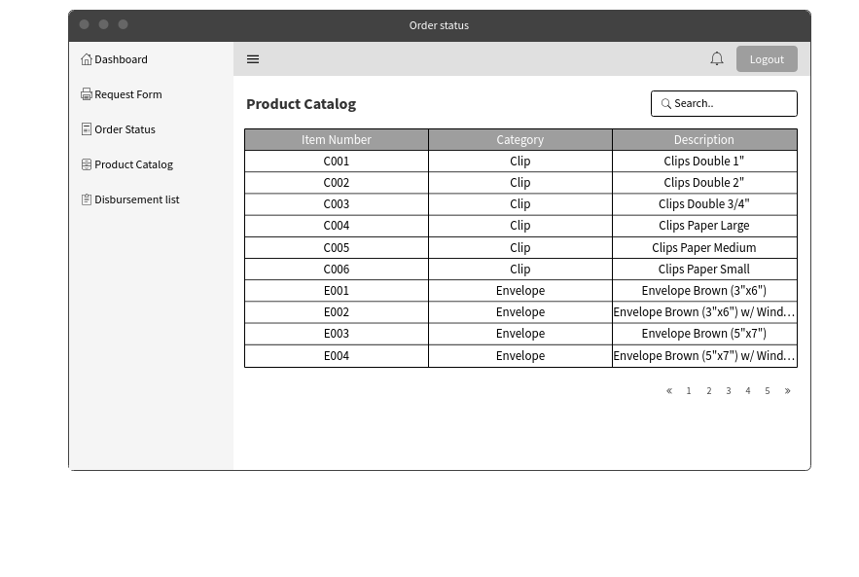

After choosing the product catalogue option on the left side of the screen, a list of stationery that is available to the employees to request. Employees are also able to search for the type of products that they are looking for.

View Disbursement List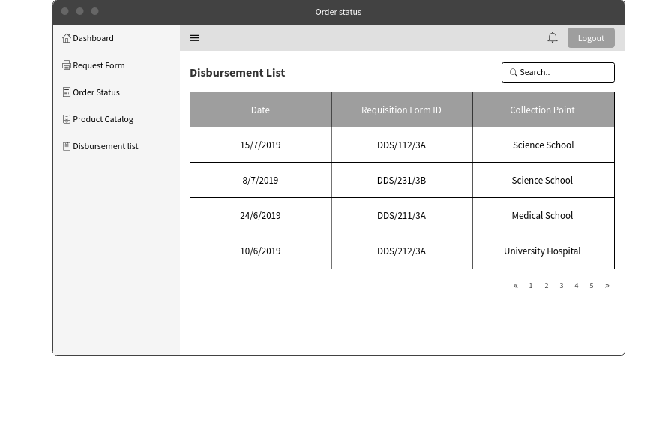

After choosing the disbursement list option on the left side of the screen, a list of disbursement list would be shown. This would allow for the department to have a copy of the disbursement list that was signed during collection. Having a copy of the disbursement list would help the departments during times of dispute about the stock amount collected or amount to make payment.

Appoint Location (Designated Collection Point)

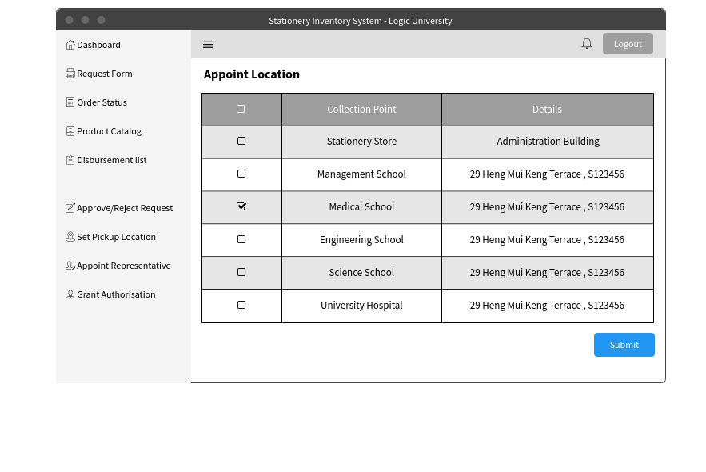

The following screen will be seen and used by the department head. The Department Head will be able to select their department’s chosen location from the listing of available locations. Upon clicking “submit”, it will be set for all stationery orders until the next change.

An additional functionality is added here whereby users are unable to change this location once the day crosses Wednesday 18:00 hours. This is to prevent collection location from changing at the last minute when store clerks are busy collecting stocks and assembling them from disbursement.

Approval/Rejection of Requisition Form

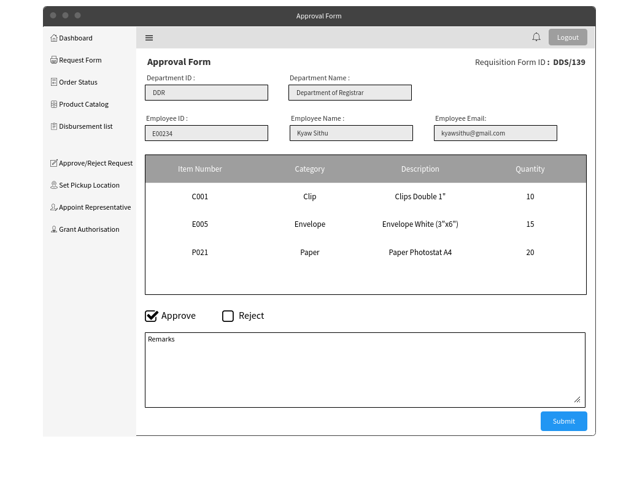

This is the view of the approval and rejection screen. The details of the employee and department would be shown on the top. The details of the stationery that the employee would like to request would be shown below the employee details. Two options of approve or reject would be given so that the decision can be made. The approver would be allowed to give their remarks when they either approve or reject the request. Upon clicking the submit button an email would be sent to the employee and the store clerk to notify them of the approval.

Appointment of Representative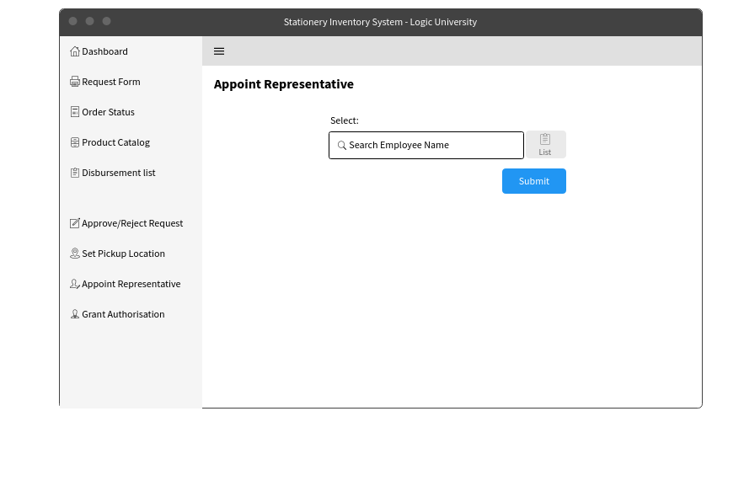

The page above will be shown after clicking on the appointed representative option on the left. An employee name can be entered or clicking the list button will show a list of employee’s name. Upon clicking submit, an email notification will be sent to that specific employee.

Authorizing Department Staff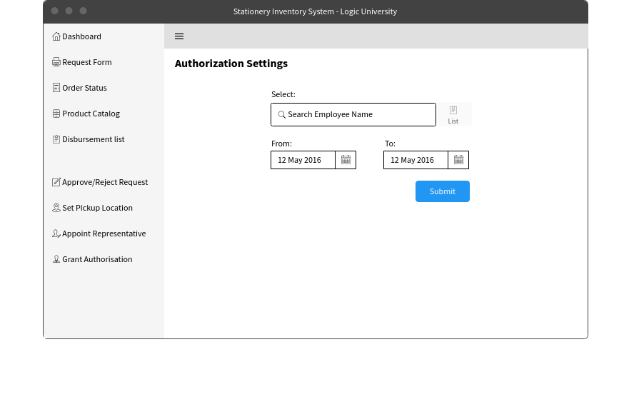

Above shows the authorization page that is accessible by Department Heads. Here, the Department Heads are able to assign approval role to their staff. They will also need to choose a duration of which they want to assign this role to. For easy viewing, an Employee List is included by the side for reference, so that Department Heads are able to view their staff list in the event they require it.

#### 

#### 2.1.3.2 Department Android UI

Below UIs are the android screens for Department Head.

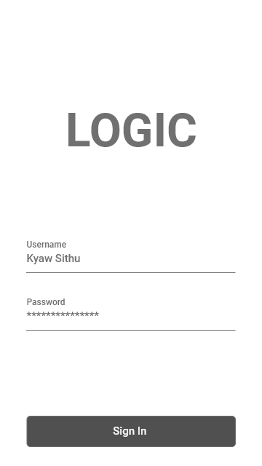

Enter correct username and password to sign in to account.

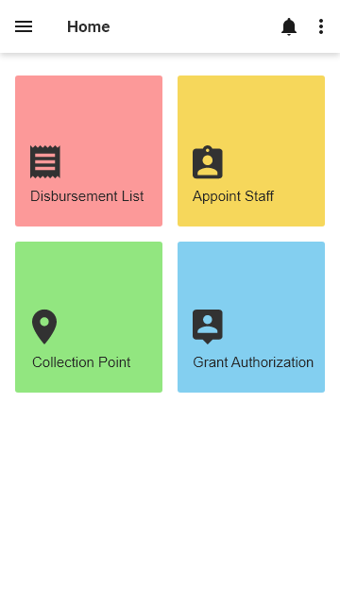

This is the home page for department android application. Clicking the disbursement button will lead you to disbursement list. To appoint representative and collection location, click appoint staff and collection point respectively. Grant Authorization button is to give permission for staff to approve or reject the requisition when the department head is on leave.

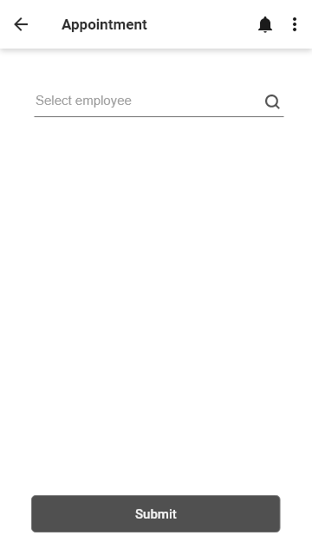

Search for the employee and submit to appoint as department department representative. The search box support with auto-complete and suggestion box.

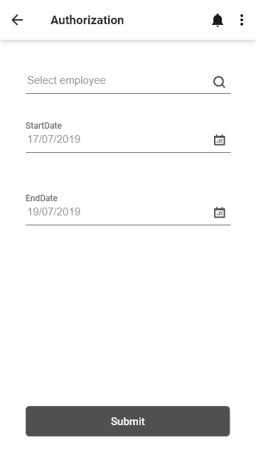

Search employee, select start date and end date to grant permission to that employee.

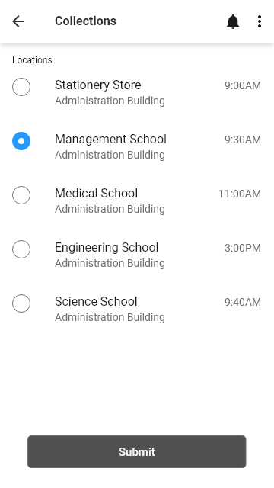

The following list is the collection point locations. Select one to choose which place to collect the ordered items.

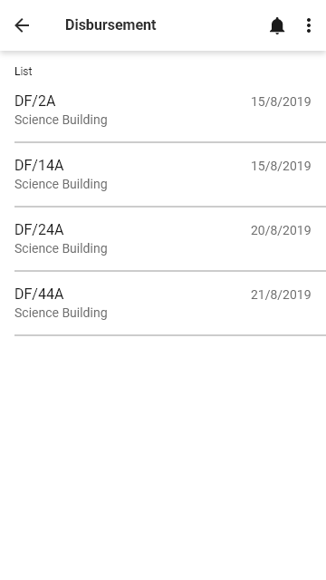

The following list is the disbursement list. Click one to check which items the store be in debt to the department

#### 2.1.3.3 Store UI

Home Page

Once user is logged in, he will be lead to the homepage, where user will be able to click the menu bar and view list of menu on the side.

### 

### 

Stationery Catalogue For Store

### 

### 

Stationery Catalogue For Store

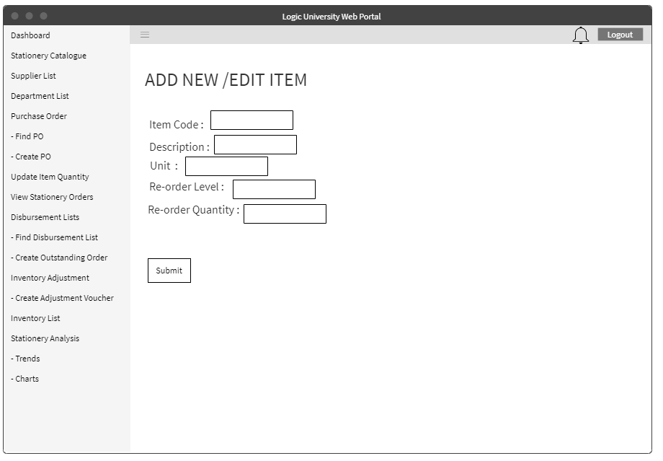Store clerk will be able to refer to the stationery catalogue and make an edit for that particular item.

### 

Stock Card

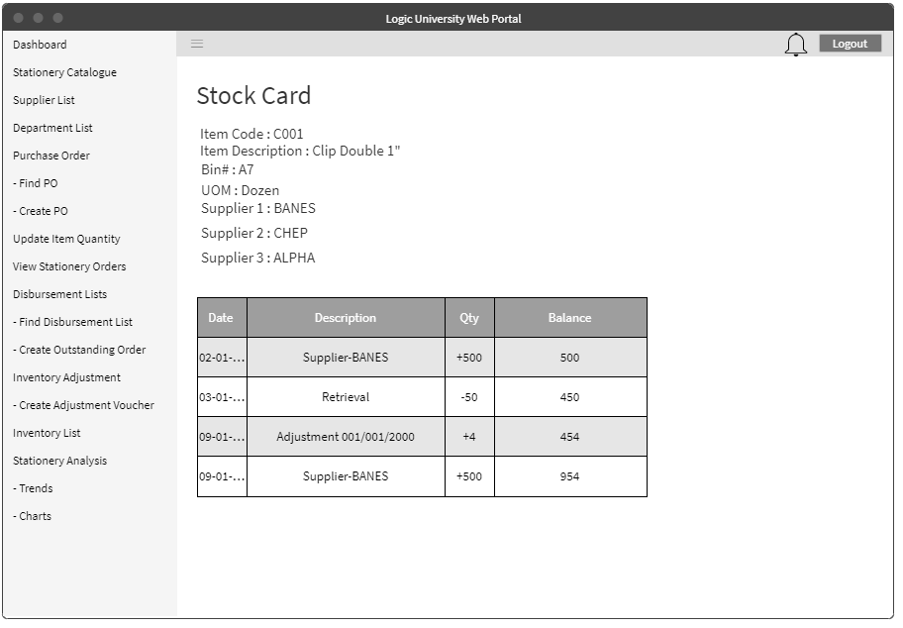In addition, each item will have its own stock card and accessible via the stationery catalogue.

### 

Supplier List for Store Clerk and Store Supervisor

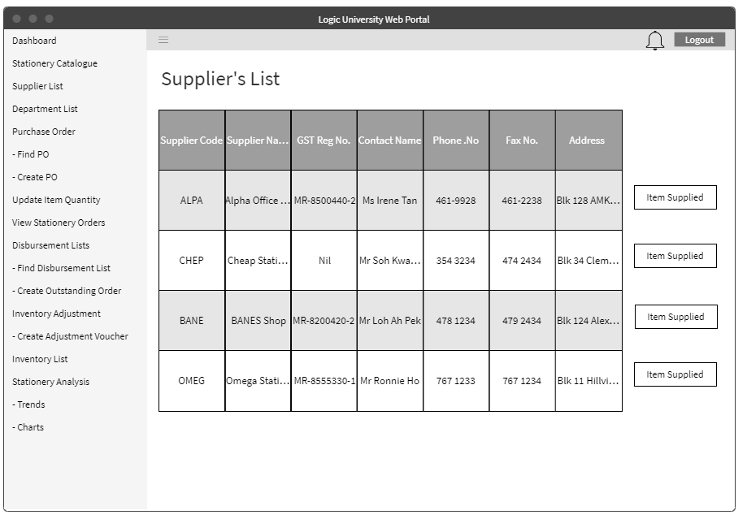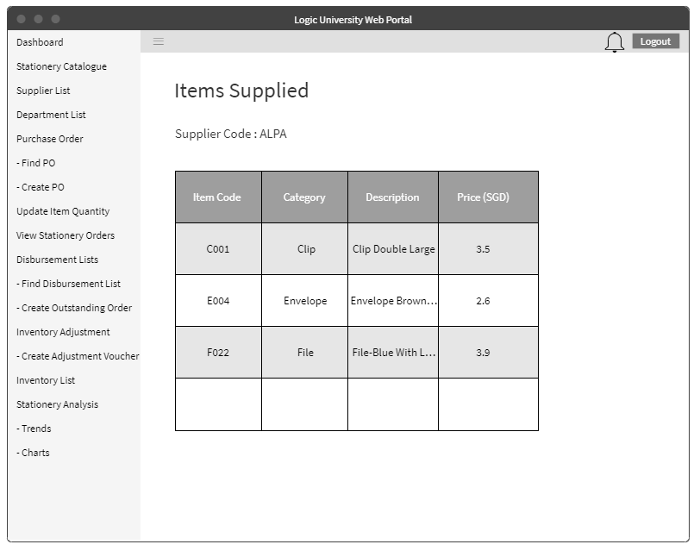

Store Clerk and Store Supervisor will be able to check supplier’s list and the items supplied by that supplier.

Department List for Store Clerk

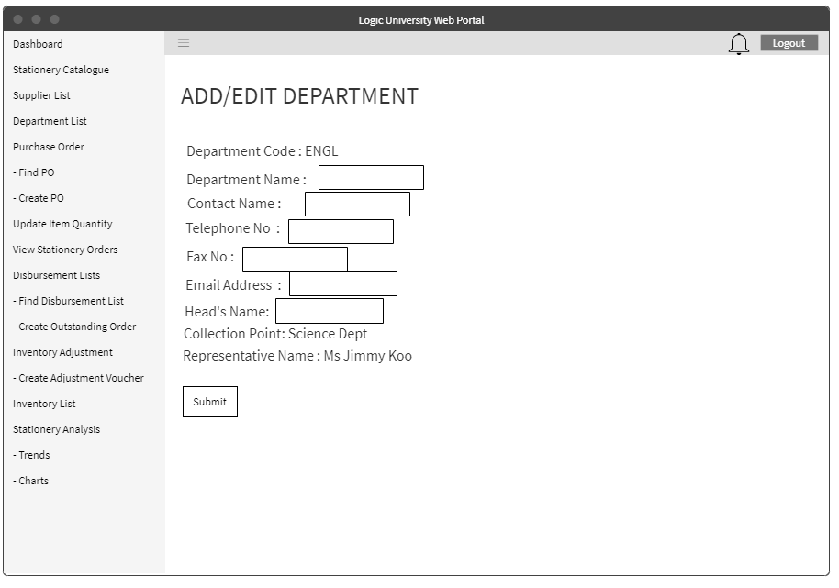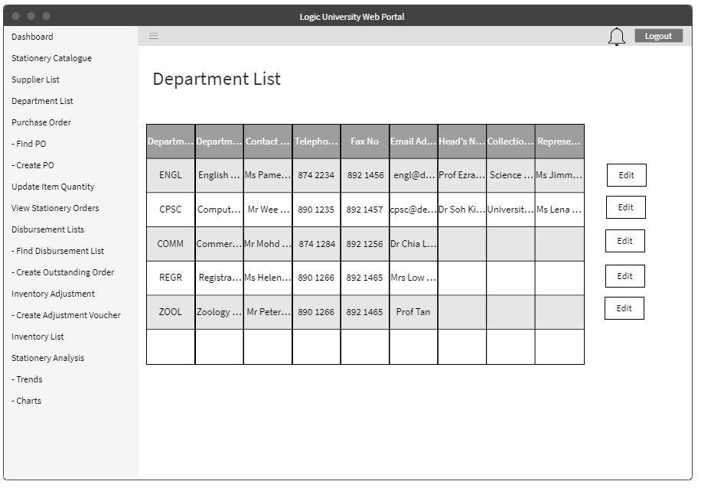

For Store Clerk, he will be able to see the department list and modify some details for that particular department.

Create Purchase Order

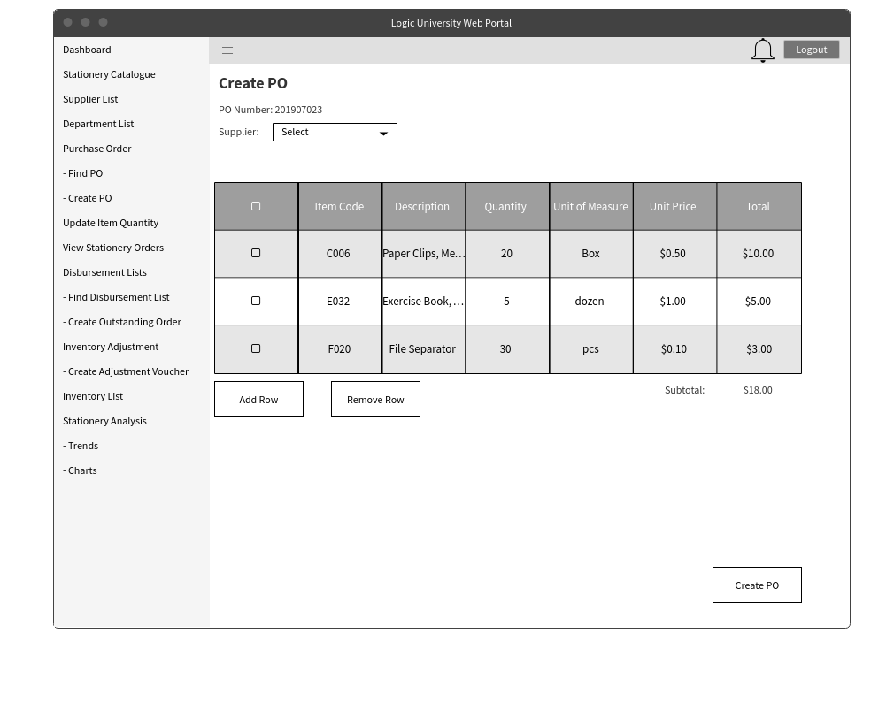

This would be the screen for creating a purchase order. The user would be able to choose the supplier and also the inventory that would be purchased from that supplier. Upon clicking the Create PO, it would be sent to the supervisor or manager for approval.

Purchase Order List

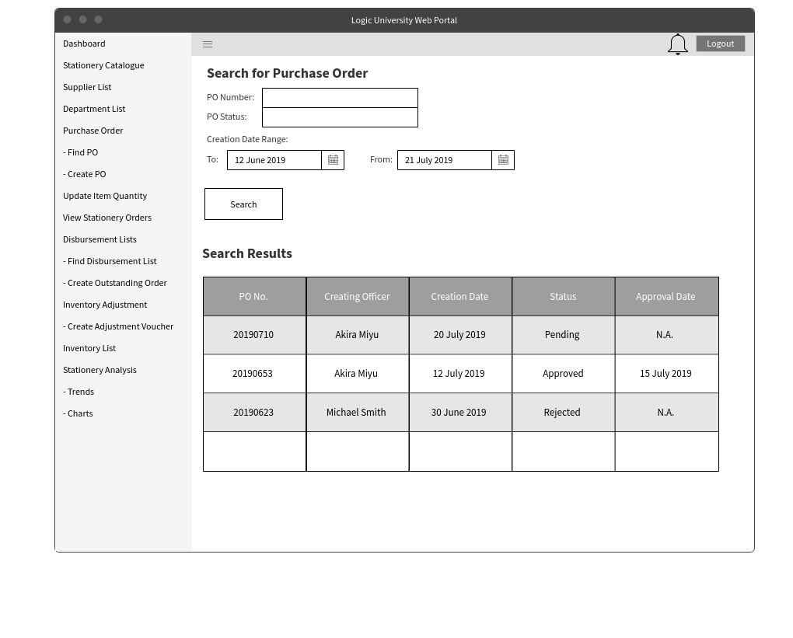

Viewing of the whole purchase order list can be done here. The option to filter the purchase order by either number, status or dates is also available.

View Purchase Order Details

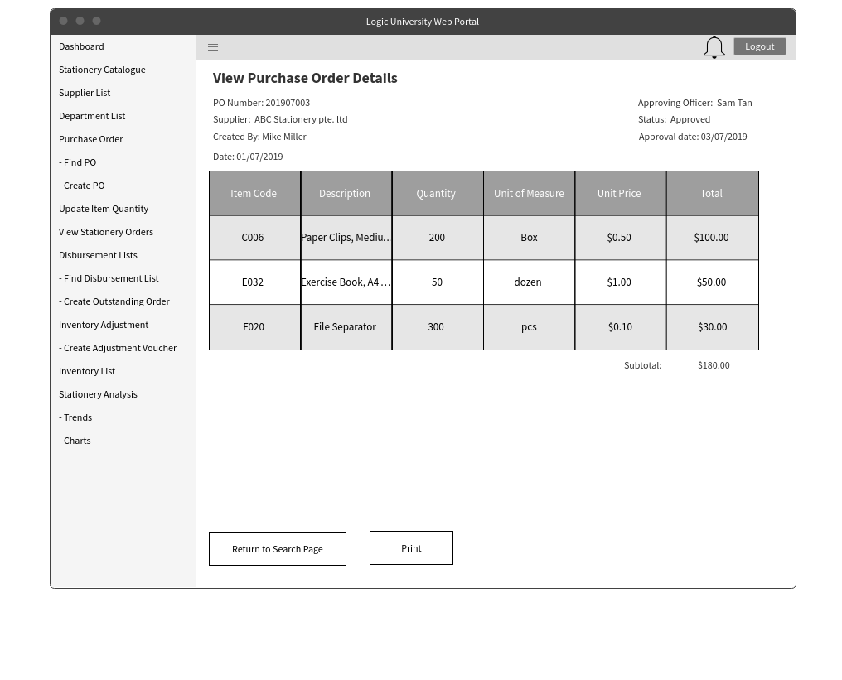

After searching for a particular PO, the detailed view will be shown. It would consist of the item details, price, quantity and the total price of the PO.

List of Disbursement List

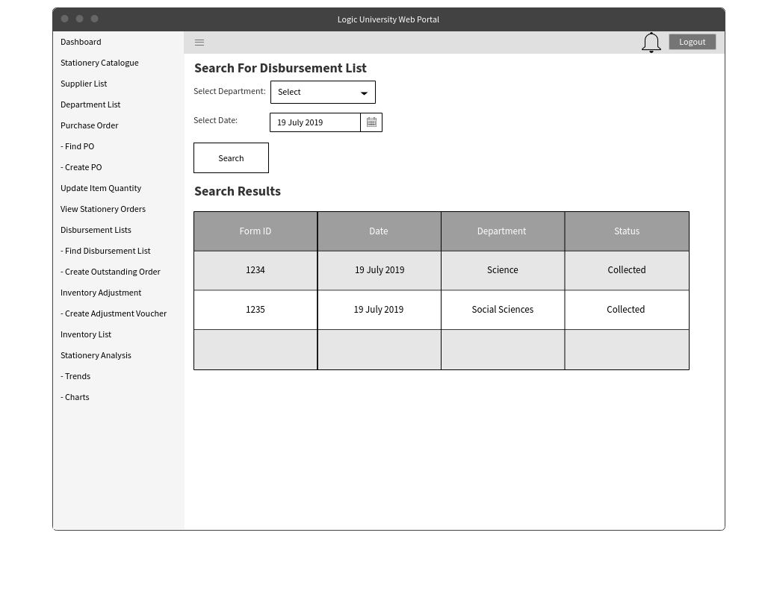

Viewing of all disbursement lists can be done here. The option to filter the purchase order by either department or dates is also available.

Detailed Disbursement List

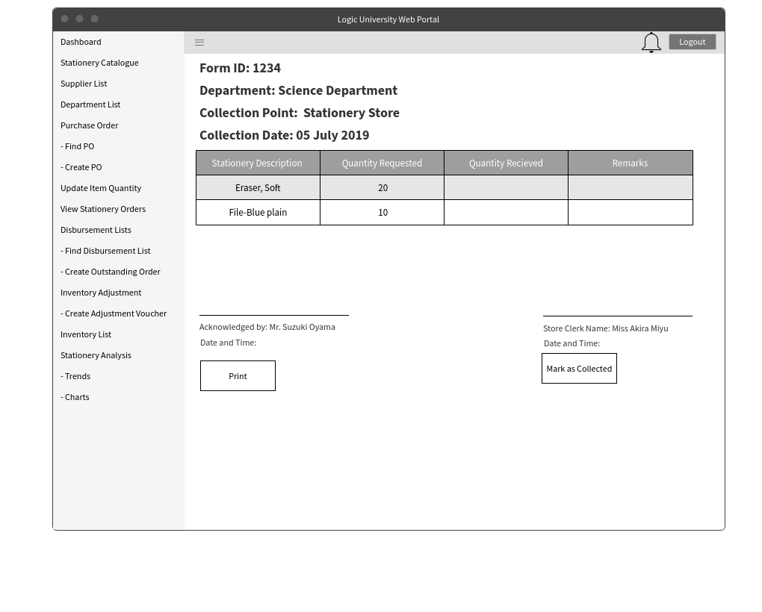

After searching for a particular Disbursement List, the detailed view will be shown. It would consist of the item details, quantity received and quantity collected.

Update Item Quantity

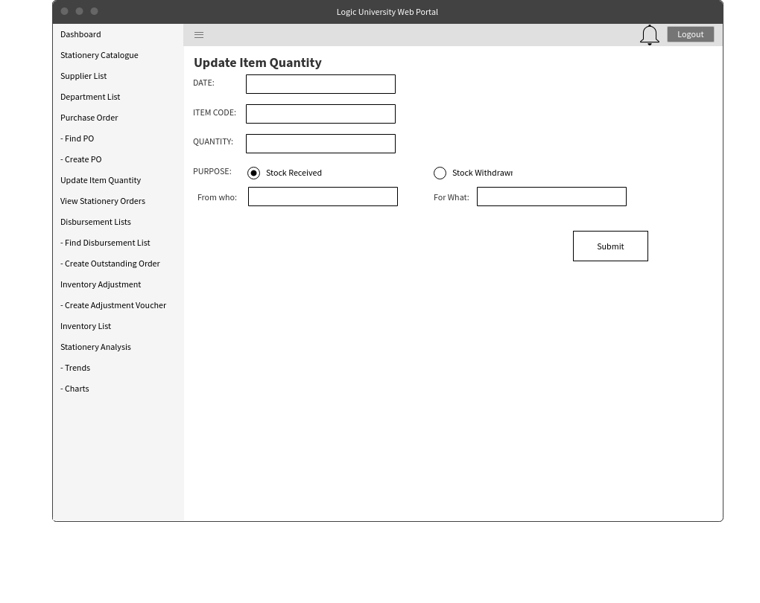

This would be the screen for updating item quantity. This would be used in scenarios where items arrive from the supplier or removed from the warehouse. The user would be able to input the date, item code quantity and also whether it was stock received or withdrawn.

Inventory Retrieval Form

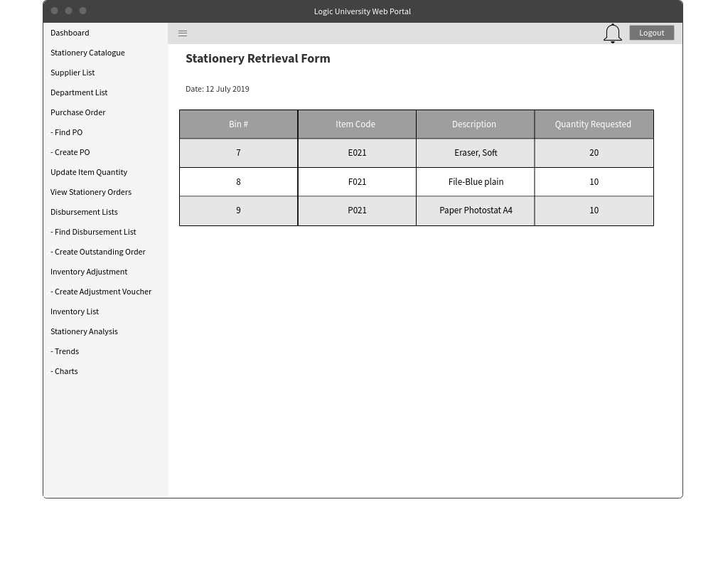

Viewing of all the items that need to be withdrawn from the warehouse based on all the requisition forms submitted. The user would be able to view the item details, its location and the requested quantity.

Create Inventory Adjustment Voucher

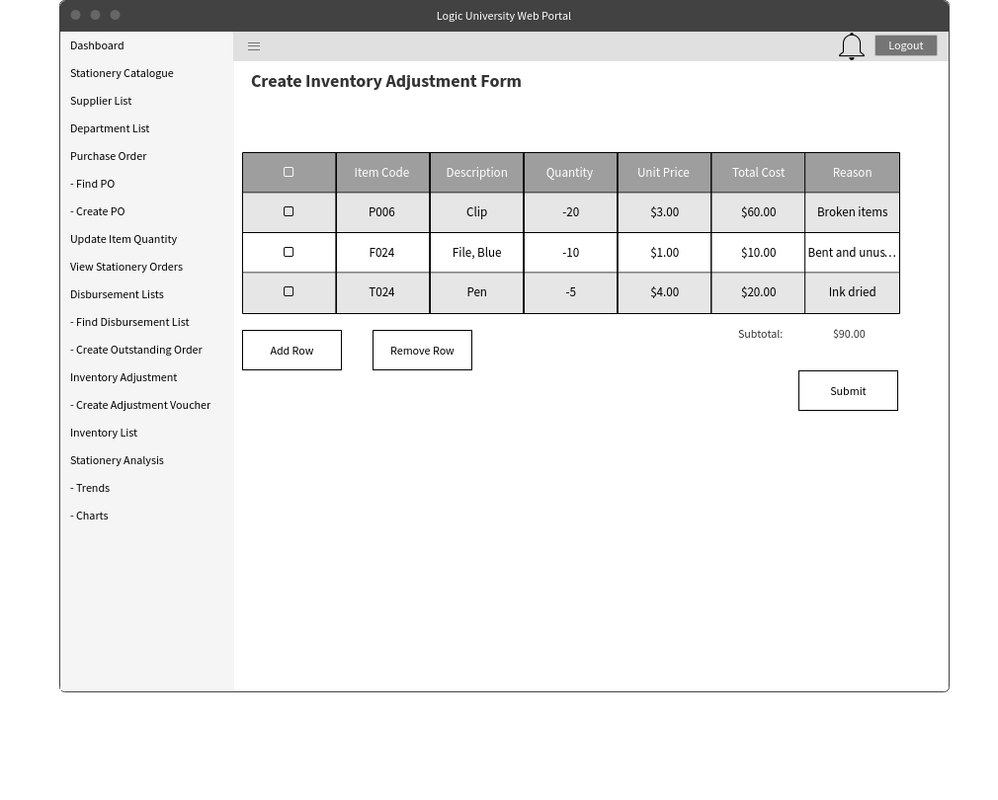

The adjustment of the inventory is done here. Adding row would create a next row to input the item.

Inventory List

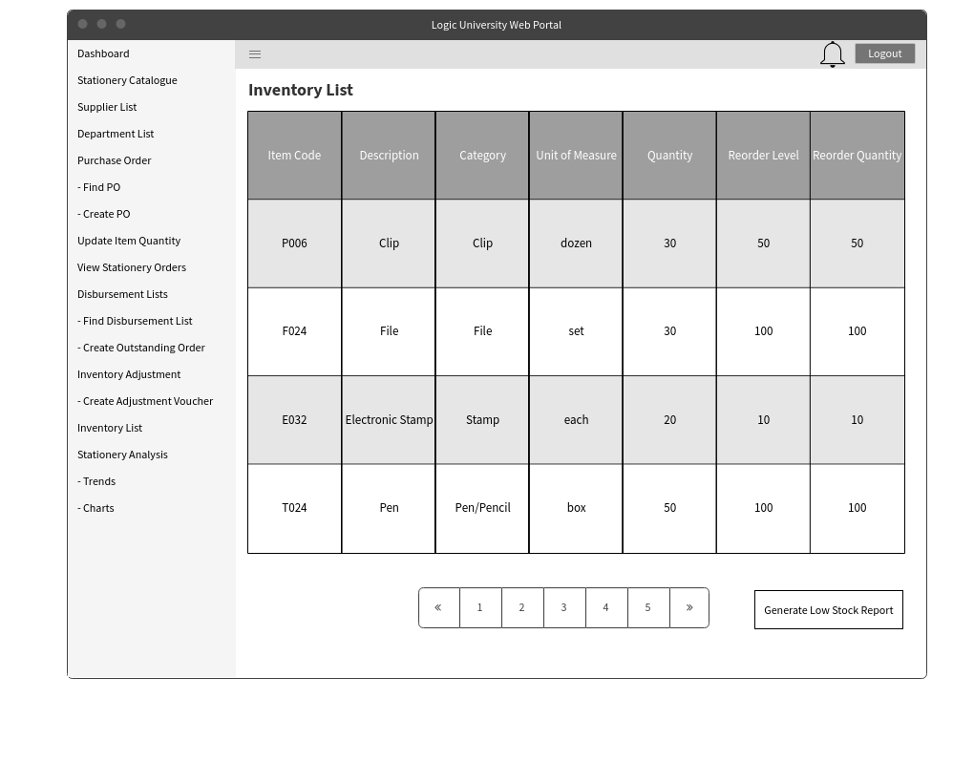

This is the screen that the store clerk would use to view the product catalogue.

Low Stock Report

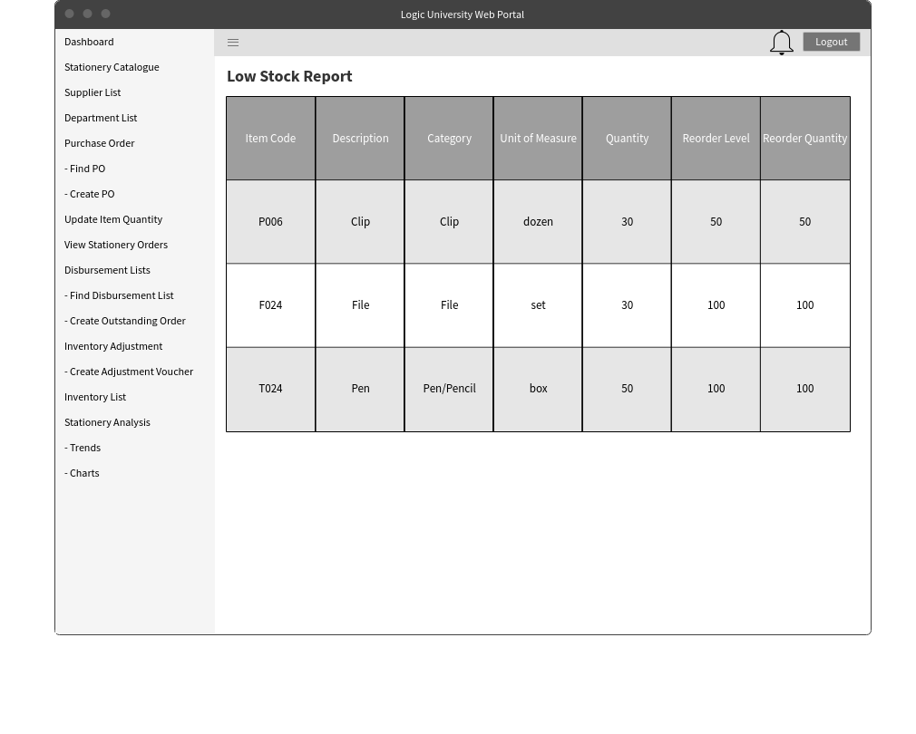

This would be the view of all stocks that low in stock.

View Stationery Orders

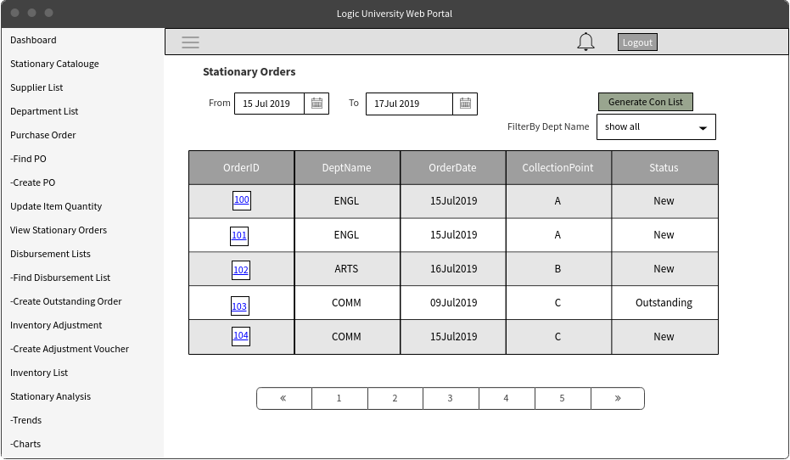

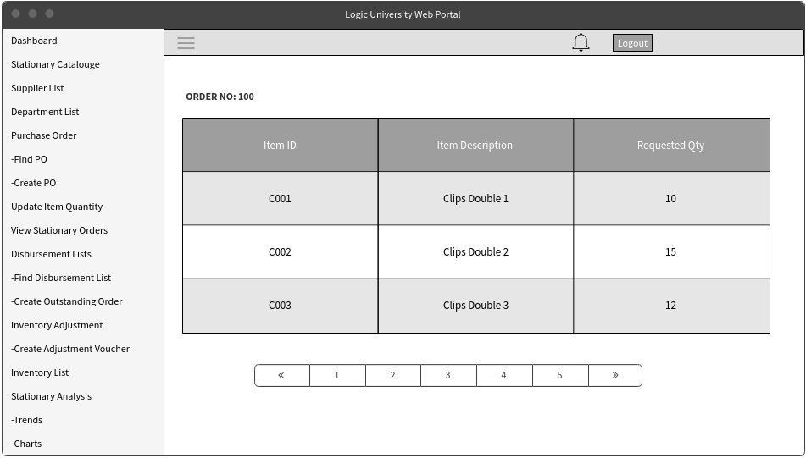

This Screen is to view all the Orders which were placed on that week by filtering with From Date and To Date and when we click on the Order Link in the previous screen we can view the details of a particular Order

Approve Purchase Order

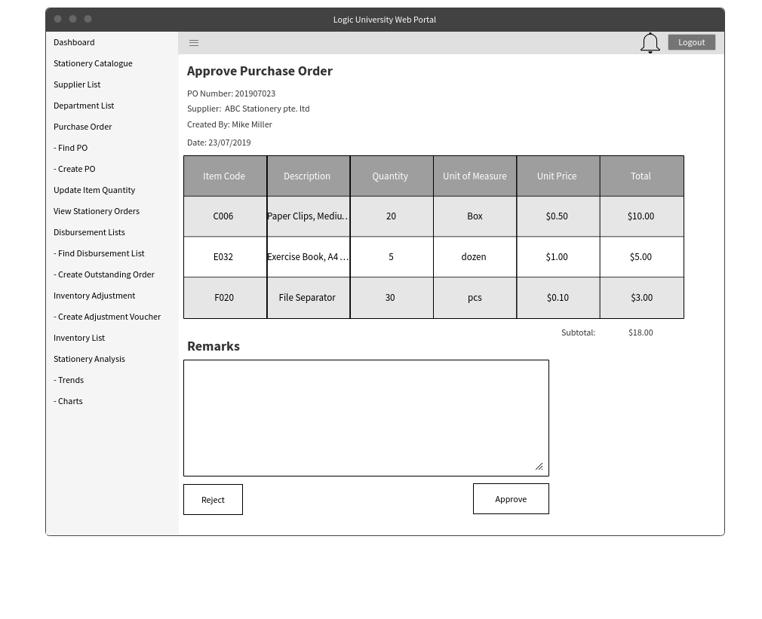

This is the screen that the store supervisor uses to approve/reject purchase order that the clerk has ordered.

Approve Inventory Adjustment Voucher

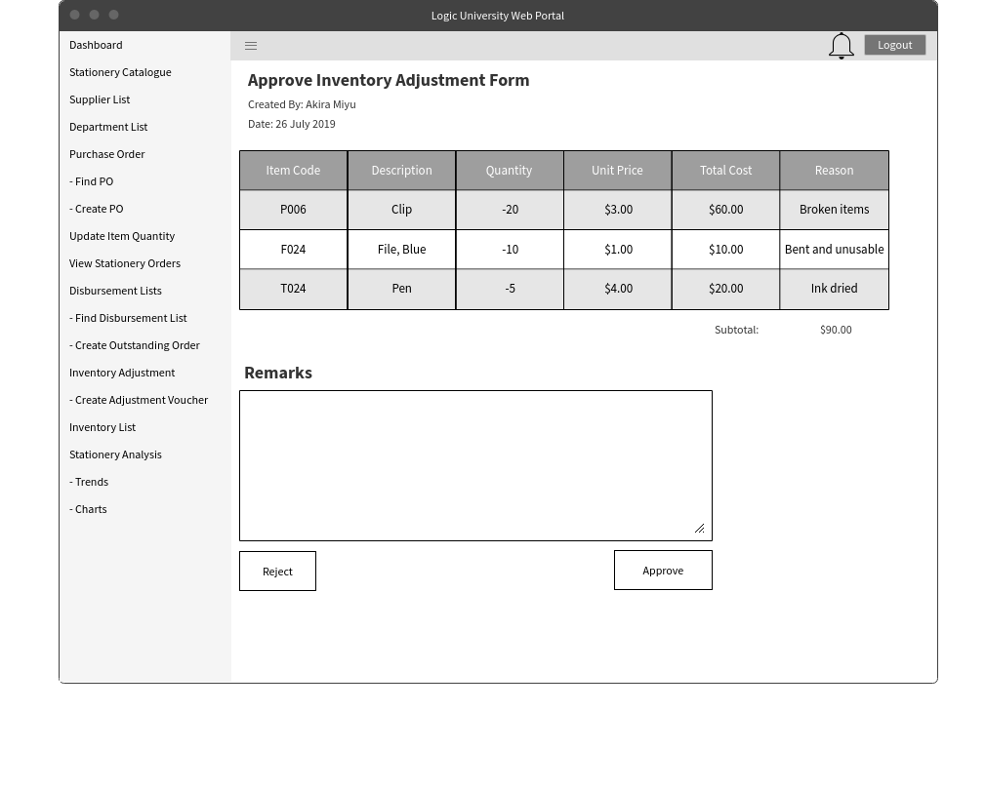

This is the screen that the store supervisor and manager uses to approve/reject the adjustment voucher that the store clerk has created.

Supplier List for Store Manager

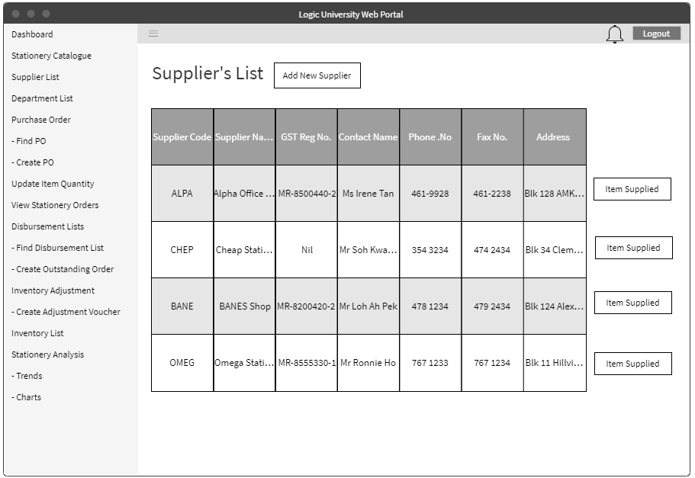

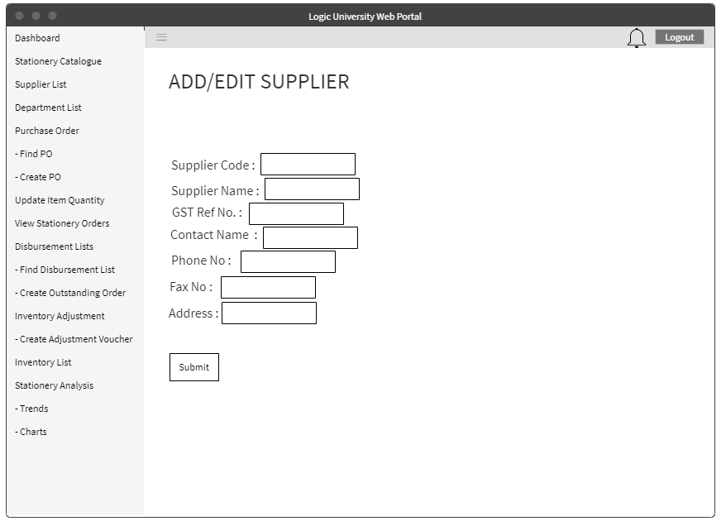

For Store Manager, he/she will be able to modify the supplier’s details.

Items Supplied for Store Manager

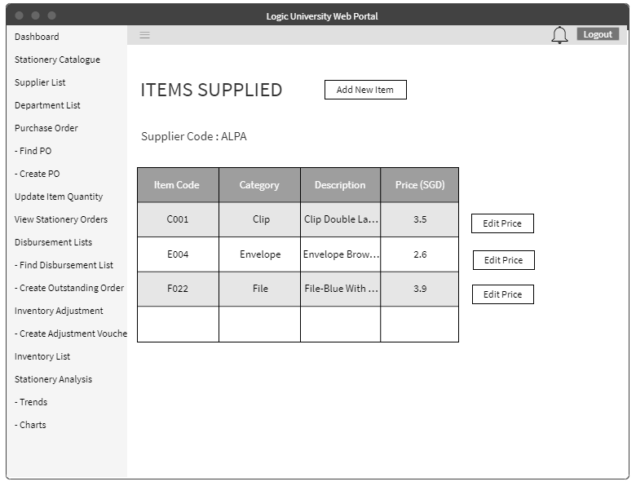

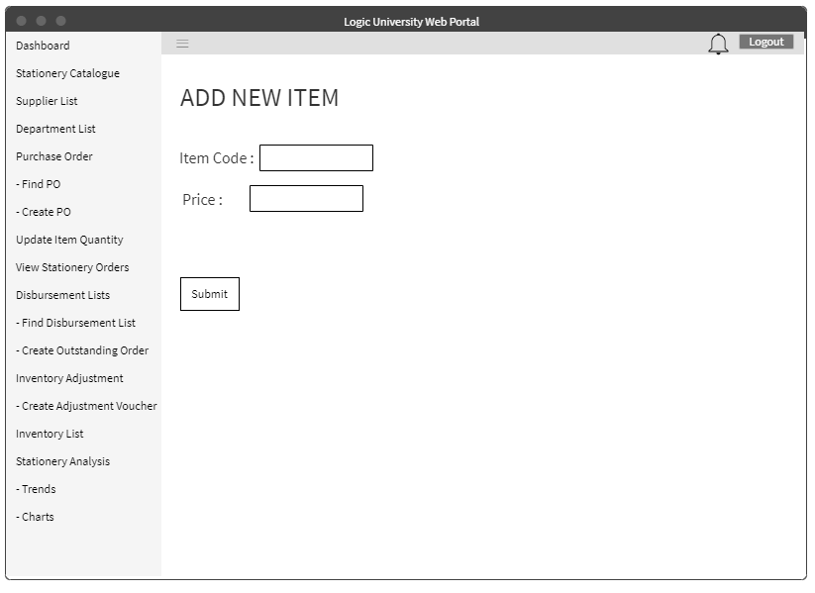

## 

For Store Manager, he/she will be able to modify(add new items and edit price) of the items supplied by that particular supplier.

## 

## 

## 

## 

## 

## 2.2 Architectural Platform

## 

## 

## 2.3 Sequence Diagram

### 2.3.1 Department Sequence Diagram

#### 2.3.1.1 Create Requisition Form

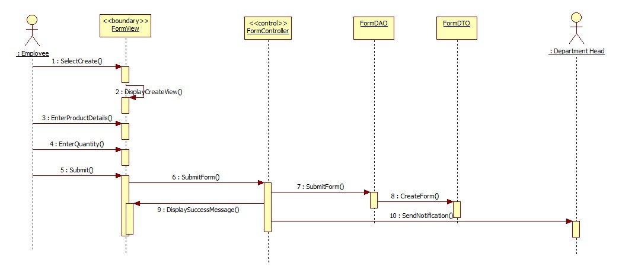

#### 2.3.1.2 Approve Requisition Form

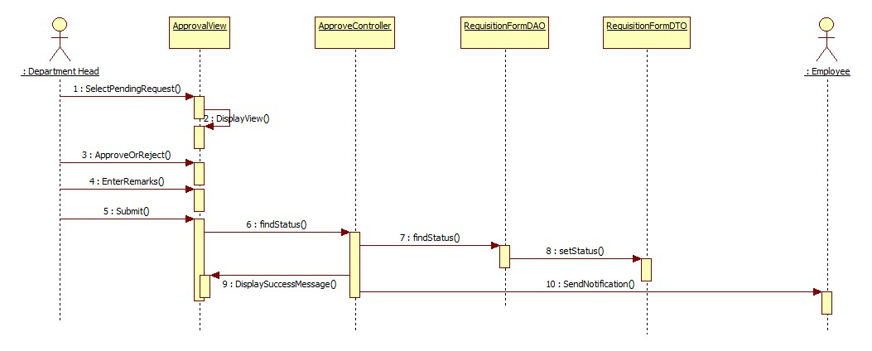

#### 2.3.1.3 Appoint Substitute Approver

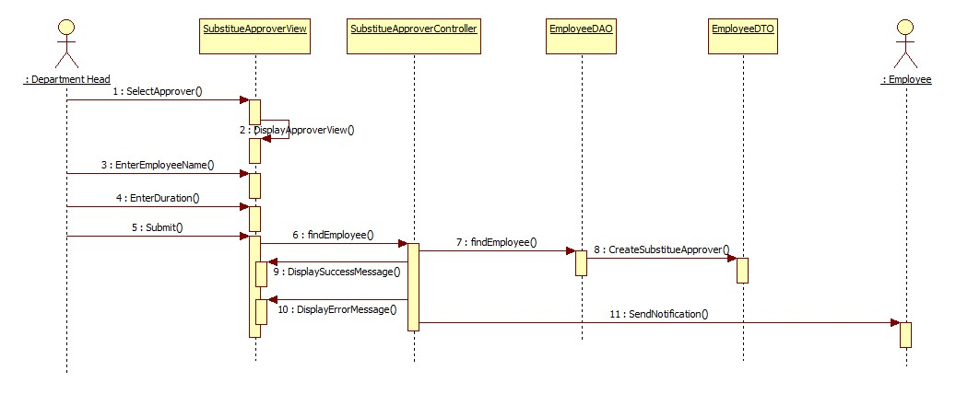

#### 2.3.1.4 Appoint Department Representative

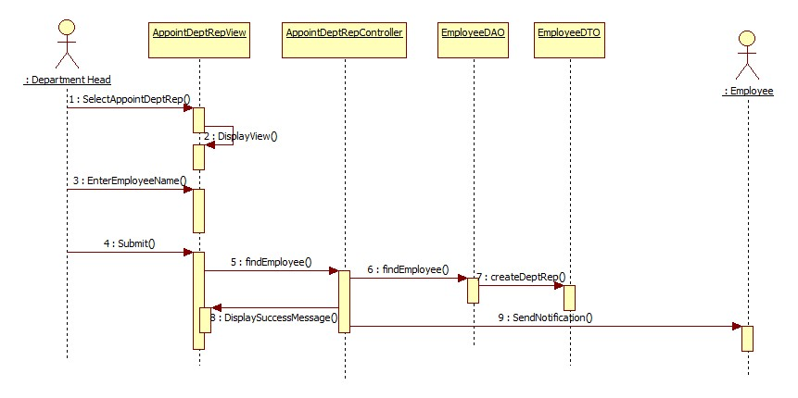

#### 2.3.1.5 Set Collection Point

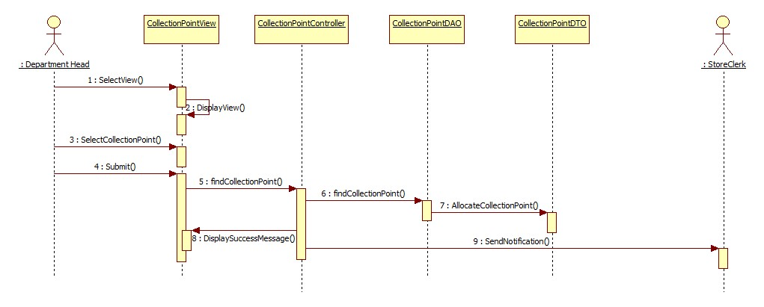

### 2.3.2 Department (Android) Sequence Diagram

#### 2.3.2.1 Set Collection Point

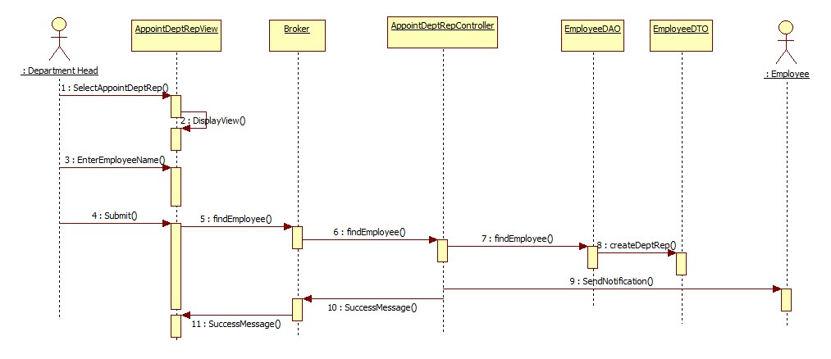

#### 2.3.2.2 Appoint Substitute Approver



#### 2.3.2.3 Appoint Department Representative

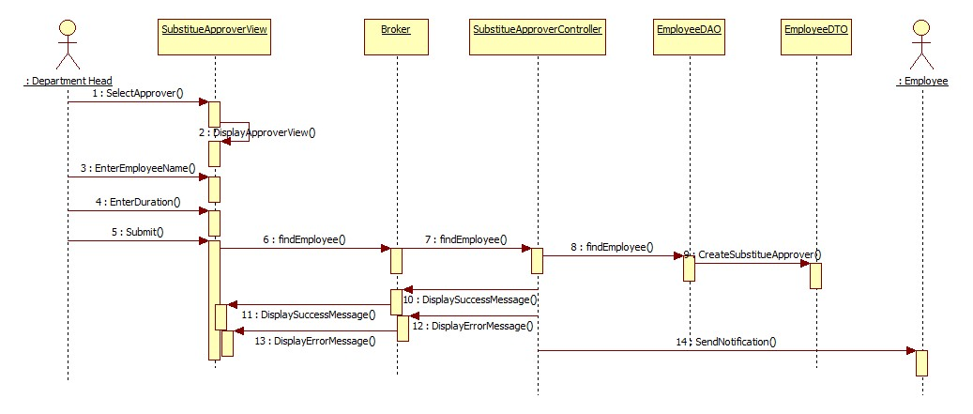

### 2.3.3 Store Sequence Diagram

#### 2.3.3.1 Retrieve Product Info

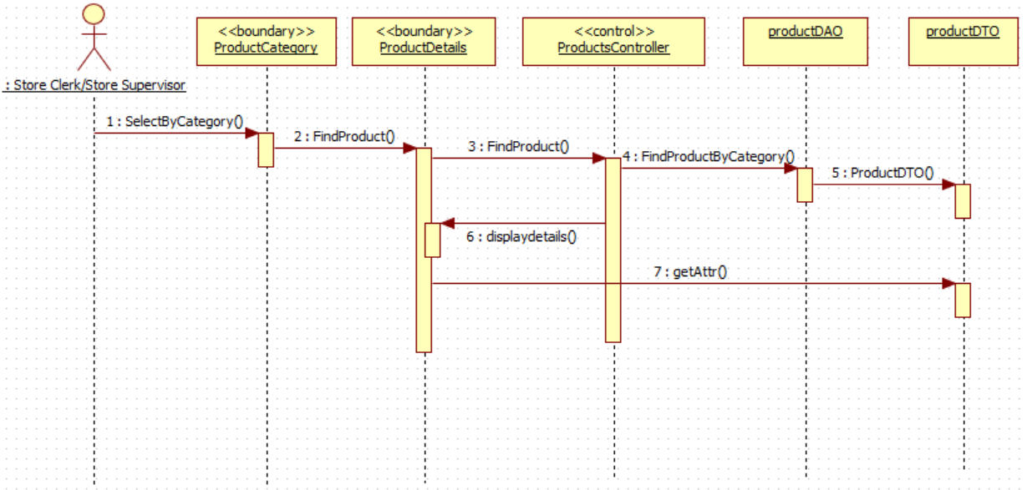

#### 2.3.3.2 Retrieve Stock Card

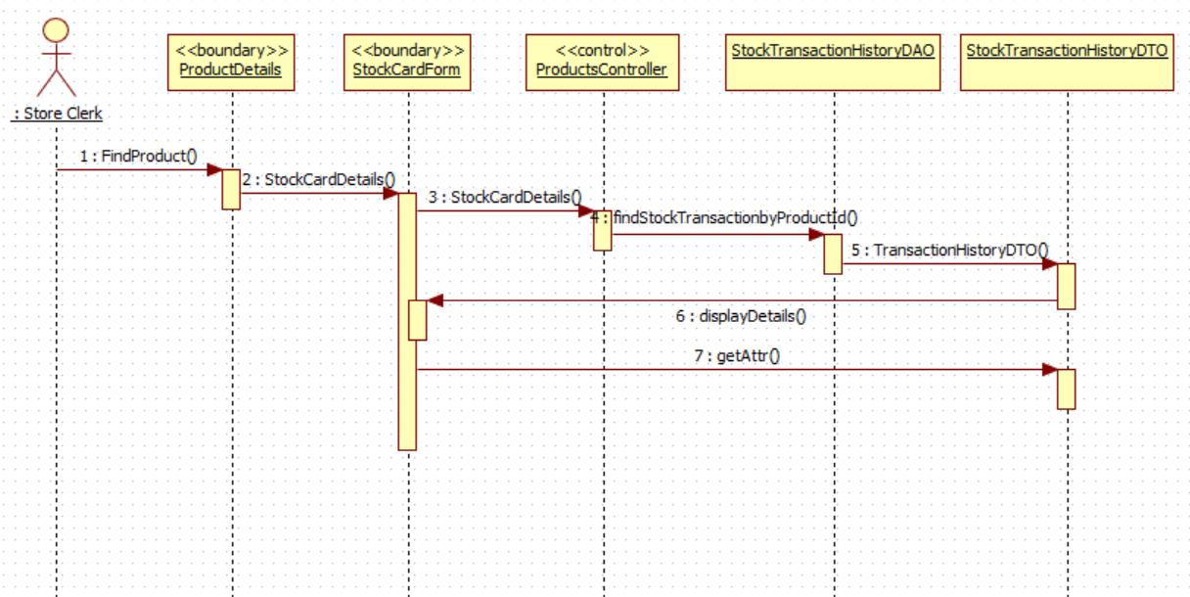

#### 2.3.3.3 Maintain Stationery Details

#### 2.3.3.4 Maintain Supplier Details

#### 

#### 2.3.3.5 Maintain Department Details

#### 2.3.3.6 Consolidated Request List

#### 2.3.3.7 Create Adjustment Voucher

#### 2.3.3.8 View Low Stock Inventory

#### 2.3.3.9 View Inventory List

#### 2.3.3.10 View Stationery Requisition Trends

#### 2.3.3.11 View Department Requisition Trends

#### 2.3.3.12 Approve Adjustment Request- Store Supervisor

#### 

#### 2.3.3.13 Approve Adjustment Request- Store Supervisor

#### 

#### 2.3.3.14 Maintain Purchase Order

#### 

#### 

#### 2.3.3.15 Approve Purchase Order

#### 

#### 2.3.3.16 View Disbursement List

#### 

#### 

#### 

#### 

#### 2.3.3.17 Confirm Disbursement List

#### 2.3.3.18 Create Outstanding Order

#### 

#### 

#### 

#### 

#### 2.3.3.19 Update Item Quantity

#### 

## 2.4 Class Diagram

### 2.4.1 Department Class Diagram

#### 2.4.1.1 Collection Point

#### 2.4.1.2 Appoint Department Representative and Substitute Approver

#### 

#### 

#### 2.4.1.3 Create And Approve Request

#### 

### 

### 2.4.2 Department (Android) Class Diagram

#### 2.4.2.1 Appoint Department Representative and Substitute Approve

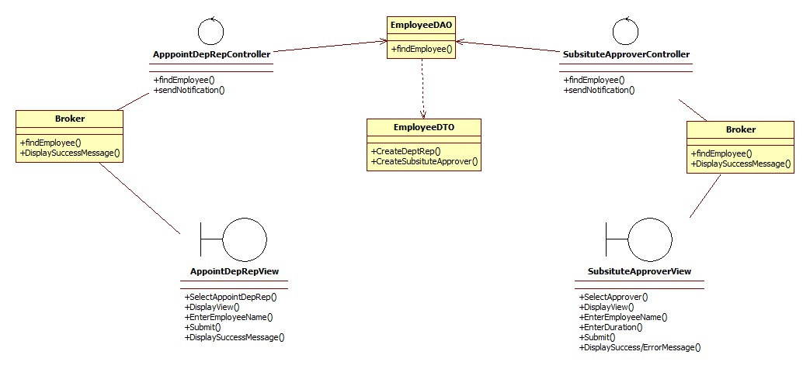

#### 2.4.2.2 Collection Point

### 

### 2.4.3 Store Class Diagram

#### 2.4.3.1 Maintain Stationery Details

## 

#### 2.4.3.2 Maintain Supplier Details

#### 

#### 

#### 

#### 

#### 

#### 

#### 

#### 

#### 

#### 2.4.3.3 Maintain Department Details

## 

#### 2.4.3.4 Consolidated Request List

#### 2.4.3.5 Purchase Order

#### 

#### 2.4.3.6 Disbursement List

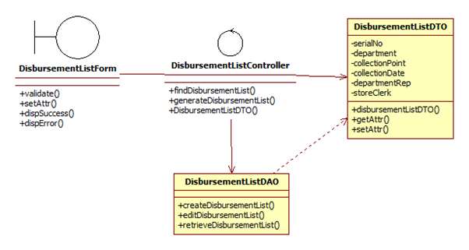

#### 2.4.3.7 Updating of Item Quantity

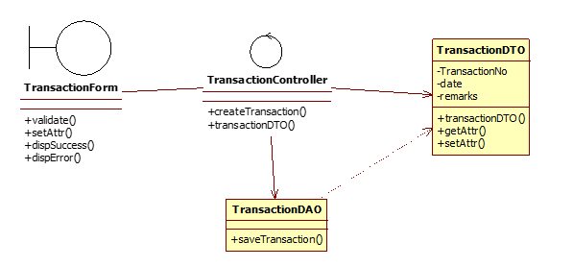

#### 2.4.3.8 Creating Outstanding Order

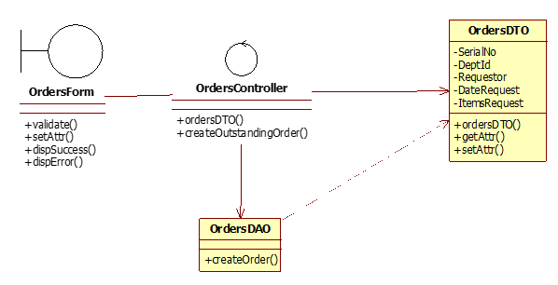

#### 

## 2.5 Statechart Diagram For Store and Department

### 2.5.1 Store

### 2.5.2 Department

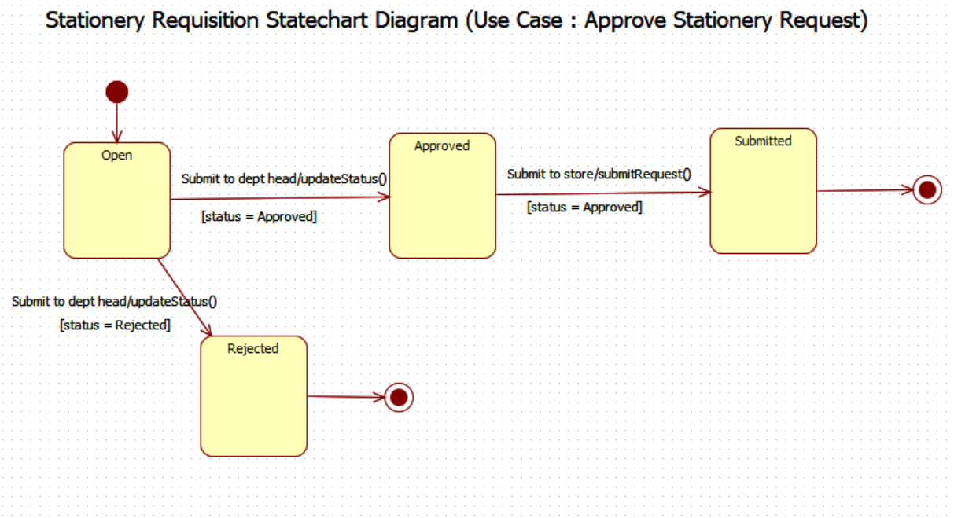

## 2.6 Relational DB Design

## 

## 2.7 Test Plan

### 2.7.1 Department

|  |  |  |  |
| --- | --- | --- | --- |
| Test Type: Unit Integration/System Acceptance | | | |
| Test ID: 1 | Prepared By/Date:  Harbinder | Tested By/Date:  Hui Ching | |
| Test Description:  Create Requisition Form | | Program Tested:  Boundary Class:  CreateFormUI  Control Class:  FormController  Entity Class:  Request,RequestDetails | |
| S/N | Test Steps | Expected Results | Actual Results |
| 1 | Log into System using Department Staff | System logs in and displays Department Dashboard | Successfully Login and the department dashboard was shown. |
| 2 | Navigate to “Stationery Requisition Form” using the left sidebar | Page loads and Requisition form is displayed | On clicking Stationery Requisition Form, the from display was shown with blank fills. |
| 3 | Select a category of item, followed by a specific item in the preceding dropdown lists.  Adjust quantity as required with entering via textbox or “+/-” button | Category loads in dropdown lists, items are searchable in typeahead search.  Quantity is adjustable | Upon choosing a category from the dropdown list, the item information from that category was chosen from the specific dropdown list. Also, quantity was entered into the box and adjustment was made via the “+” to increase the value. |
| 4 | Add new lines to increase types of items to order by clicking “Add row” at the top | Upon clicking “Add Row”, a new row is created to enter a new product category | Clicking the “Add Row” Button, added a row and the blank fills were filled by using the same method as S/N 3. |
| 5 | Once form has been successfully filled in, click “Submit” button at the bottom of the page. | Stationery form is submitted.  To check - click “Order Status” on the left and status should be “Pending” for this new order | After clicking the submit button, the page was redirected to show a new order with “Pending” status. |

|  |  |  |  |
| --- | --- | --- | --- |
| Test Type: Unit Integration/System Acceptance | | | |
| Test ID: 2 | Prepared By/Date:  Hui Ching | Tested By/Date:  Wei Sheng | |
| Test Description:  Approval of Requisition Form | | Program Tested:  Boundary Class:  ApproveFormUI  Control Class:  ApproveFormController  Entity Class:  Requests,RequestDetails | |
| S/N | Test Steps | Expected Results | Actual Results |
| 1 | Log into System using Department Head | System logs in and displays Department Head Dashboard | Successfully Login and the department dashboard was shown. |
| 2 | Navigate to “Order Status” using the left sidebar | Page loads and list of stationery orders are displayed | List of requests with different status shown. |
| 3 | Click “Approve” for a current pending order in the list | Request Approval page will be displayed, with a text box for “Remarks” and “Approve/Reject” button below | Details of the requisition form was displayed. Clicking the approve button redirect the page back to the “Order Status” |
| 4 | Enter Remarks if required and click “Approve” | Status will be updated. Upon clicking “Details” in list, full details of order as well as updated status will be reflected. | Clicking the “Details” option showed the order details with the Status being shown as  “Approved”. |

|  |  |  |  |
| --- | --- | --- | --- |
| Test Type: Unit Integration/System Acceptance | | | |
| Test ID: 3 | Prepared By/Date:  Wei Sheng | Tested By/Date:  Kyaw | |
| Test Description:  Appointing a Department Representative | | Program Tested:  Boundary Class:  DeptRepUI  Control Class:  DepRepController  Entity Class:  DepartmentStaff, Department | |
| S/N | Test Steps | Expected Results | Actual Results |
| 1 | Log into System using Department Head | System logs in and displays Department Head Dashboard | Successfully Login and the department dashboard was shown. |
| 2 | Navigate to “Appoint Representative” using the left sidebar | Page loads and a dropdown box with “Submit” button is displayed | Page loads and a dropdown box with “Submit” button is displayed |
| 3 | Search for employee name via typing, or choose an employee name by selecting from dropdown list | Employee Name is searchable and Employee Name is selectable. | Employee Name is searchable and Employee Name is selectable |
| 4 | Click “Submit” once representative has been chosen | Successful appointment will be shown via a pop up. | Successful appointed shown via a pop-up |

|  |  |  |  |
| --- | --- | --- | --- |
| Test Type: Unit Integration/System Acceptance | | | |
| Test ID: 4 | Prepared By/Date  Kyaw: | Tested By/Date:  Harbinder | |
| Test Description:  Set Collection Point | | Program Tested:  Boundary Class:  CollectionPointUI  Control Class:  CollectionPointController  Entity Class:  CollectionPoint, Department | |
| S/N | Test Steps | Expected Results | Actual Results |
| 1 | Log into System using Department Head | System logs in and displays Department Head Dashboard | Successfully Login and the department dashboard was shown. |
| 2 | Navigate to “Set Collection Point” using the left sidebar | Page loads and a list of collection points are displayed | Page loads and lists of collection points are displayed |
| 3 | Choose a collection point from the list and hit “Save” once chosen | Collection Point is saved. | Collection point is saved |

# 

### 2.7.2 Store

|  |  |  |  |
| --- | --- | --- | --- |
| Test Type: Unit Testing | | | |
| Test ID: 1 | Prepared By/Date:  Koh Zhen Xiang | Tested By/Date:  Antonio | |
| Test Description:  Withdrawal / Retrieval of Stationery and Creation of Disbursement List | | Program Tested:  Boundary Class:  InventorySubMenuUI, CreateRetrievalFormUI, FindDisbursementListUI, DetailedDisbursementListUI  Control Class:  InventoryController  Entity Class:  Products,Disbursements,Requests,RequestDisbursementDetails | |
| S/N | Test Steps | Expected Results | Actual Results |
| 1 | Log into System using Store Clerk Credentials | System logs in and displays  Store Clerk dashboard | Successfully log in as store clerk and relevant dashboard are shown |
| 2 | Navigate to “Inventory Management” from the sidebar menu and click on ‘Withdraw Inventory from Store’ link | Clicking on the ‘Withdraw Inventory from Store’ link will lead to the page of stationery requested by all departments. | After clicking the ‘Withdraw Inventory from Store’ link, the page shows all the stationery requested by all the departments. |
| 3 | Enter the retrieved quantity in the text box and click ‘Submit’ | -The retrieved quantity entered into the text box will reduce the number of quantity in the store after submission (confirm via checking the stock card)  - A disbursement list will be generated automatically after clicking the ‘submit’ button (eg. if Department A request for 5 item of item C001, the disbursement list will be generated for Department A after we retrieved the item). | After inserting the number of quantities retrieved and clicking the ‘Submit’ button, a new disbursement list is created and the total quantity balance of this item is reduced when checking the stock card. |
| 4 | Select ‘Disbursement List’ from the sidebar menu. | Find the disbursement list based on the department or date to confirm if the disbursement list is created after the submission in the inventory retrieval form.  The list of disbursement list will have two status :  - **Delivered** : when the stationery has been disbursed to the department representative.  - **Pending :** when the stationery has not been disbursed to the department representative. | Selecting disbursement list via department or date shows all disbursement list after the submission of the retrieval form.  The list consists of disbursement lists with both **Pending** and **Delivered** status |
| 5 | Select a particular disbursement list. | For the disbursement list with **Delivered** status, the page will show the quantity requested and quantity received by the department.  For the disbursement list with **Pending** status, the page will have a text box to insert the quantity received by the department and remarks for any comments. This is done when the department representative and store clerk meet at the collection point to deliver the stationery. After delivered, pressing the ‘Mark as Delivered’ button will change the status to **Delivered.** | The newest disbursement list is resulted from the creation of retrieval form (from test plan No 3 above). The status for this list is **Pending** as the item has not been distributed.  Store Clerk is able to enter the total item received by department and add in any remarks.  Upon meeting with the department representative, store clerk is able to select ‘Mark as Delivered’ button to indicate item has been disbursed and delivered to the department.  The disbursement list status is now changed to ‘**Delivered**’ |

|  |  |  |  |
| --- | --- | --- | --- |
| Test Type: Unit Testing | | | |
| Test ID: 2 | Prepared By/Date:  Antonio | Tested By/Date:  Koh Zhen Xiang | |
| Test Description :  Maintain Supplier List | | Program Tested:  Boundary Class:  SupplierListUI, ItemSuppliedUI, EditSupplierUI, DeleteSupplierUI,  CreateSupplierUI, CreateItemSuppliedUI, DeleteItemSuppliedUI  Control Class:  ManagerController  Entity Class:  Supplier, SupplierProducts,Products | |
| S/N | Test Steps | Expected Results | Actual Results |
| 1 | Log into System using Store Manager Credentials | System logs in and displays Store Manager dashboard | Store Manager page and dashboard is loaded after login |
| 2 | Navigate to “Supplier Information” on the sidebar menu | Page loads and list of supplier details are shown | Page is loaded and supplier details are shown |
| 3 | Click on “Add new Supplier” button to add supplier | Page will show the list of text boxes for store manager to fill in the new supplier details and Click on ‘Create’ button to add new supplier. | Text boxes are shown for store manager to enter the new supplier details and clicking on the ‘Create’ button add a new supplier. |
| 3 | Click on ‘Edit’ button to modify supplier details | Page will allow manager to modify the supplier details and upon clicking the ’Save’ button will reflect the latest changes. | Supplier details are updated to the latest information after the changes are done. |
| 4 | Click on ‘Delete’ button to remove supplier | Page will show a confirmation to change the details and upon clicking the ‘Delete’ button will remove the supplier. | Supplier is removed from the Supplier information page. |
| 5 | Click on ‘Items Supplied’ to see the stationery supplied by a particular supplier | Page will show the lists of stationeries supplied by that particular supplier. | Page loads and list of stationeries are shown for that particular supplier. |
| 6 | Click on ‘Edit Price’ to edit the price of stationery and ‘Save’ to change the price. | Allows store manager to change the price of the stationery, supplied by that particular supplier. | Price is updated after old price is changed to a new price. |
| 7 | Click on ‘Delete’ to remove the stationery for a particular supplier | Allow store manager to remove the stationery from the Items supplied | Stationery is removed from the items supplied page. |

|  |  |  |  |
| --- | --- | --- | --- |
| Test Type: Unit Testing | | | |
| Test ID: 3 | Prepared By/Date:  Koh Zhen Xiang | Tested By/Date:  Antonio | |
| Test Description :  Creation of Purchase Order | | Program Tested:  Boundary Class:  FindPOUI, CreatePOUI  Control Class:  InventoryController  Entity Class :  Supplier, SupplierProducts,Products,PurchaseOrder, PurchaseOrderDetails | |
| S/N | Test Steps | Expected Results | Actual Results |
| 1 | Log into System using Store Clerk credentials | System logs in and displays  Store Clerk dashboard | Successfully log in as store clerk and relevant dashboard are shown |
| 2 | Navigate to “Purchase Orders” using the sidebar menu | Page will load and shows the Find Purchase Order Page.  User will be given choices to find Purchase Order by searching through date or status  There will be a link for store manager to create a PO as well. | The ‘Create Purchase Order’ link is available to create a purchase order. |
| 3 | Click on ``Create Purchase Order’ link on Find Purchase Order page and select on one of the suppliers to create Purchase Order | It will lead to the Create PO with a dropdown list of supplier .  Select one of the supplier will show up a row of text box for user to include the stationery. | Selecting one of the suppliers shows up a row of text box for store clerk to enter details of an item. |
| 4 | Select a stationery **supplied** by that particular supplier from the dropdown list.  Test data : Supplier ALPA and item code C001 | Select an item that is supplied by a particular supplier from the dropdown list, will populate the rest of the text box and the ‘submit’ button will be enabled. | Selecting supplier ALPA and select item C001 does populate the item details to the respective text box and store clerk is able to proceed with the purchase order. |
| 5 | Click on ‘Add Row’ to add additional item | Clicking on ‘Add Row’ will cause a row of text box to show up and allow the store manager to add additional items to be ordered. | Selecting ‘add row’ button adds a row to add additional item |
| 6 | Click on ‘Remove’ button to remove the row | Clicking on ‘Remove’ button will cause the row to be removed from the Purchase Order. | Selecting the ‘Remove’ button removes the row. |
| 7 | Click on the ‘Submit’ button to send a Purchase Order for the Supervisor to approve | Clicking on the ‘Submit’ button will send the Purchase Order for supervisor approval and when supervisor logs in, he/she should see the list of PO pending for his/her approval. | Click on the ‘Submit’ button successfully send the Purchase Order for supervisor approval. |

# 

# 3.0 Recommendations

Recommendations :

* Using an e-authorisation for disbursement list in the dept side - Department reps can sign off via mobile phone and save the signature. We recommend this as this will significantly improve user experience and soft copies of disbursement list can be used instead of printout of hardcopies during stationery collection.
* To allow for staff to be able to request for stationery on-the-go, the create requisition form option can be implemented on to the mobile application. This would also allow the staff to be able to order without the need of being deskbound.

Future Developments :

* Implement the e-authorisation for disbursement list
* Business Intelligence - eg informing Department Head why similar multiple orders are being posted by staff. It will be able to highlight such issues, for example, multiple orders are created because stationery store did not fulfill initial request. On the store side, additional trending and charting (such as projected stationery consumption trend based on current year data) can be implemented.
* Improve UX (User Experience) - To improve usability, to implement changes such as placing all clickable buttons on the right hand side; simple easy to tell cues such as approve button in green and reject buttons in red. Another improvement will be to show current collection point like we did in authorize staff/appoint representative. This way, users will know at a glance what was the previous selection.

# 

# 4.0 Lessons Learned

* **Team collaboration** - Working as a team gave us an experience of how the real time projects work where Teamwork plays an important role.
* **Knowledge on Different Technologies** - Gained knowledge on C# programming language,Asp.net MVC Architecture,Ms SQL,Android(mobile app development),Machine Learning Models,Asp.net Entity framework,LINQ,Python language
* **Version Control** - Learning how to use tools (such as GitHub) for version control saves time and effort by ensuring that everyone is working with the latest code. It also enforces consistency (e.g. database fields and models have the same name), which helps in integration.
* **Machine Learning** - Gained knowledge on how the Machine learning models are integrated with the software for data analysis purpose.
* **Software Design phase** - Gained knowledge on how the Software design phase happens which includes Requirement Gathering ,Analysis,User Stories,Use cases,Sequence Diagrams,Class Diagrams,UI prototyping.
* **Project Management** - Gained knowledge on project management process which includes Project Planning,Project Scheduling,Work Distribution,Risk Management.
* **Quality Assurance** - Conducting a test plan and testing helps the team to find bugs.
* **Complete SDLC** - Learnt how the complete software development process happens from the Requirements gathering phase to Deployment phase
* **Deployment environment** - Learnt additional configuration steps when setting up the production environment, and also additional considerations when deploying the solution online (Different compared to running on own computer)
* **Testing is Very Important** - Learnt that testing is crucial and should be done at every opportunity available.

# 

# 5.0 Problems and Solution

|  |  |
| --- | --- |
| Problem | Solution |
| Codes of querying from the existing class does not give the desired result. | Create a new class which include some of the database column where the data we desired existed in these columns. For example, in order to show a list of items supplied by a supplier, we create a class of ‘View Model’ which consists of Supplier, Supplier Product and Product class |
| Faced problems in designing the system, particularly in coming up with good database design. | Team has completed the initial database design on time but later discovered that initial design cannot meet the complete requirements as some of the requirement details could not be captured.Team spent some extra time to come up with the good database design covering all the requirements which helped us in the later stages of coding to go in a smoother way. |
| Faced difficulties in standardising our codes and diagrams due to different working styles. | For design we together as team discussed and came up with the templates for the sequence diagram and UI.For Implementation our team had a good amount of discussions to come up with certain coding convention and the structure to follow. |
| Code interfering with each other during integration because different libraries (e.g. JQuery) were imported | In order to ensure the various scripts in the program (especially Javascript) do not conflict with each other, the libraries imported have been agreed upon first to minimise the conflict. |

# 

# 6.0 Looking Back

* Could make more use of DAO pattern in some of the code and logic as the controller method is supposed to link the View and Model, instead of accessing the data layer directly. Also, certain business functions can be put in a service class to further loosen the coupling in the system.
* Clearer communication amongst team members as sometimes team members may not be doing things according to plans.
* A more thorough discussion on the Entity Relations Database, as we have to modify it a few times for this project. Also need to factor in additional time for ERD, as it is likely changes would need to be made as the coding progresses.
* The programmers should have constantly delivered the functional code of the particular module developed to the team,so that all the team members can test the code instead only the developed person testing the code.Small Incremental development will make testing easier which in turn reduces the number of bugs from the initial stage.